36/1/4/1(201800272)
NATIONAL ASSEMBLY

FOR WRITTEN REPLY QUESTION 2797
DATE OF PUBLICATION IN INTERNAL QUESTION PAPER: 14 SEPTEMBER 2018 (INTERNAL QUESTION PAPER NO 30-2018)

2797. Mr M Bara (DA) to ask the Minister of Police:

- Whether, with reference to his reply to question 1540 on 4 June 2018, and in view of the fact that the Sebenza Police Station has four sectors which should have two vehicles patrolling in each sector at all times, by what date will the station receive additional sector vehicles in order to ensure it meets the prescribed standards;

- are there any additional sector vehicles needed for (a) sector managers and
(b) any other police personnel; if so, (i) what number and (ii) by what date will the station receive additional vehicles?

REPLY:

(1)

(2) (2)(a)(i)
(2)(a)(ii)
(2)(b)(i)
(2)(b)(ii)
NW3090E

The Sebenza Police Station will receive three additional sector vehicles, by 2018-11-30.
The station requires the following additional vehicles: Two vehicles are required for sector managers.
No additional vehicles will be allocated for this financial year. One vehicle is required for other police personnel.
No additional vehicles will be allocated for this financial year.

Reply to question 2797 recommended/

LE(SOEG)
Date: l8’DD’ £D

ONE
GENERAL TH AFRICAN POLICE SERVICE

NATIONAL AS8E#IBLY
FOR WRITTEN REPLY QUG6TION 154g
DJ\TE OF PUBLICATION INI1T* RNAL OUEgTION Pj4\PER: 18 §fAY 2016 (INTERNAL QUESTION PAPER NO 16•2018)
1540. Mr T R Me)oia (DA) to aak the Iginlater of Police:
What number of (a) vehicles a›s available k›r vBible pollclng with spectflc reference to sedor policing at tha Sebanza Pollca Station, (b) the speclflaf vehicles f›ava mileage of (I) 1-100 000 kma, (li) 100 001-20D 000 kms, (II!) 200 001400 000 kit›s and (iv) over 300 000 kms and (c) days in 2017 waa eech of the vehicles out of working ordar7

REPLY:
NW16B0E

avallable Ibr

 | Number of  vehlolea | (c) days  out of  for each vohlde, In 2017 | Number of  vehicles | (r) days  out of  eaoh veMole, In 2017 | Nuci0er of | (c) daya  out of  each vehlob, In 2017 | Number of  vahlolaa | (c) days  oct of  each vehicle, In 9017
4 | NII | NII | BTW003B  BYW006B | 4  4 | BTC57JB  BSK417B | 4  6 | NII | NII

Orlglnal aigned LIEUTENANT GENERAL PROVINCIAL 0OMMI66IONER: GAUTEMD DS DM LANQE
Dels: 22 May 2018

Reply to question 1540 recommended e

GENERAL
UTH AFI JCAN POLICE 8ERVICE

Reply to question 1M0 approved

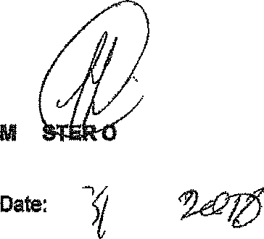
INI
F POLICE
BH CELE, MP

