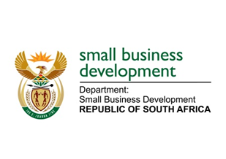
NATIONAL ASSEMBLY
QUESTION FOR WRITTEN REPL
DUE IN PARLIAMENT: 16 SEPTEMBER 2022

“2795. Mr H C C Krüger (DA) to ask the Minister of Small Business Development:
What number of business incubators that are funded by the (a) State, (b) private sector and (c) international actors exist in each province?” NW3387E

REPLY: I have been advised by the department as follows:

(a) The following Incubators are funded by the Small Enterprise Development Agency (Seda) through funding allocation from Department of Small Business Development (DSBD):
No. | Province | Number of Incubation Centres
1 | Eastern Cape | 17
2 | Free State | 6
3 | Gauteng | 36
4 | Kwa Zulu Natal | 19
5 | Limpopo | 7
6 | Mpumalanga | 10
7 | Northern Cape | 5
8 | North West | 8
9 | Western Cape | 14
 |  | 122

(b) According to data collected during 2019/20 financial year, a total of 106 incubators in the private sector were recorded. See below breakdown:
Type | No
Accelerators | 49
Incubators | 57
Total | 106

It is however difficult to get real time numbers since state funded and private sector incubators are not governed and or affiliated to a body. Seda is in a process of resuscitating the Southern African Business and Technology Incubation Association (SABTIA) which will address the intention of assessing the overall number of incubators in the country.

(c) Seda does not have data on international players per province, however Seda is co-funding an incubator with the French Embassy called French South African Tech Labs in Cape Town.

STELLA NDABENI-ABRAHAMS
MINISTER: SMALL BUSINESS DEVELOPMENT

