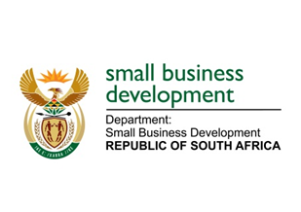
NATIONAL ASSEMBLY
QUESTION FOR WRITTEN REPL
DUE IN PARLIAMENT: 16 SEPTEMBER 2022

2794. Mr H C C Krüger (DA) to ask the Minister of Small Business Development:
What plans has she put in place to support the small, medium and micro enterprises sector to participate in the Small-Scale Embedded Energy (SSEG) value chain?”
NW3386E

REPLY: I have been advised by the department as follows:

A general approach adopted by the Department is to understand the quantum of financing and activity in specific value-chains within the sector. With this perspective, it was noted that renewable energy is clearly the most substantial sector currently, and opportunities were identified for specialised SMMEs who provide the technical services and products required at different stages of development and operation. Technologies such as solar water heating, bioenergy, smart grids and smart meters provide considerable opportunities across the board for SMMEs. Beyond the various product and service sectors and value chains, another key area of intervention is to support SMMEs to make them greener, more sustainable and thereby more competitive.

The Department has looked at mechanisms to support SMMEs within targeted sectors, using all instruments at their disposal. This includes:
- Business Development Support, incubation.
- Ensuring specialised technical and quality support for SMMEs.
- Plans are afoot to look at preferential and specialised financial assistance and incentives.
- Policies to set-aside or ringfence a percentage of the value of projects or products for SMMEs in defined value-chains, sub-sectors and state procurement.
- Localisation and demand-side policies.
- Export support.

The Department is also looking at supporting SMMEs to become more sustainable and to adopt green practices through partnership with the Department of Fisheries Forestry and the Environment (DFFE) and the Department of Mineral Resources and Energy (DMRE) looking at the following specific measures:
1. To publicise, support and facilitate access by SMMEs to the full range of energy and resource- saving services.
2. Encourage and incentivise SMMEs to install embedded power generation technologies as it becomes economically feasible.
3. Promote the concept of circularity and the efficient manufacture and sustainable use of materials and resources.

STELLA NDABENI-ABRAHAMS
MINISTER: SMALL BUSINESS DEVELOPMENT

