36/I/4/1(2021)
NATIONAL ASSEMBLY

2792. Ms Z Majozi (IFP) to ask the Minister of Police:

Whether, in light of the recent crime intelligence report that has revealed that kidnappings in the Republic rose by 60% in 2021, his department has investigated allegations that members of the SA Police Service and private security companies were involved in kidnappin8•, if not, why not; if so, what are the full, relevant details?
NW3307E
REPLY:

Private security companies form part of the multidisciplinary operational approach, which was adopted for the tracking and tracing of kidnappers and the rescuing of victims, in collaboration with the South African Police Service (SAPS).

Families of a kidnapped victim will typically approach a private security company of their choice, who in turn, according to the investigative procedures will be the mediator between the Jolnt Operational Centre (JOC) and the family of the victim. They are referred to as partners or stakeholders and collaboration is not limited to kidnappings but can include all other categories of crimes, which are problematic.

There is currently no reported case or incident where private security companies were involved in the commission of such a crime, identified as an accomplice or an accessory after the fact.

Members of the SAPS and other law enforcement agencies, have been arrested in the following cases:
- Pretoria West, CAS 280/01/2021: Two City of Tshwane Metropolitan Police officials were arrested. The matter has been provisionally withdrawn, pending the tracking and tracing of the complainant.

. 2

Johannesburg Central, CAS 1054/02/2019: Nine suspects were arrested, of which two are members of the SAPS. The case has been set for trial arrangement, on 15 January 2022.
- Parkview CAS 142/08/2019, Bramley CAS 182/01/2020 and Rosebank CAS 61/02/2020: Five suspects were arrested, of which two are members of the SAPS. The same suspects were arrested in all three abovementioned cases and the case will be heard, in February 2022, for trial.

Reply to question 2792 recommended/

R:

E (SOEG)
Date: ygjj .jj- g
GENERAL

AFRICAN POLICE SERVICE

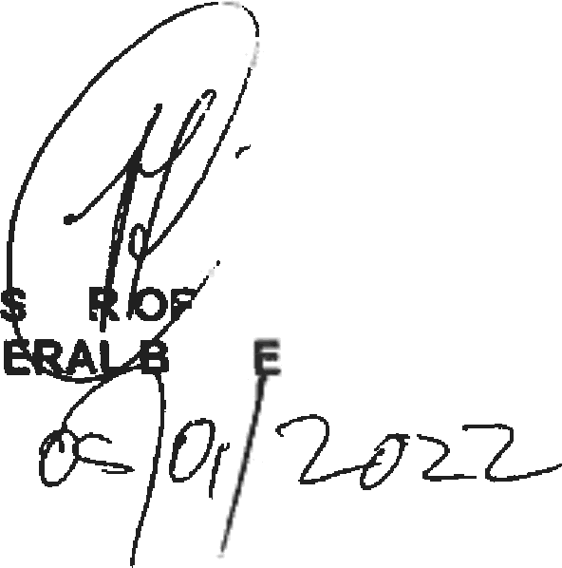
Reply to question 2792 approved/red

MINI TE POLICE
GEN H C LE, MP

Dare:

