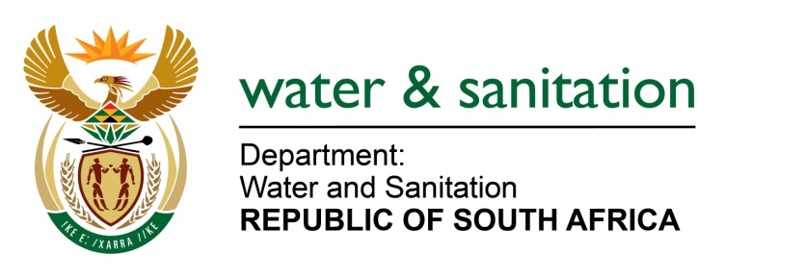

NATIONAL ASSEMBLY

FOR WRITTEN REPLY

QUESTION NO 2791

DATE OF PUBLICATION IN INTERNAL QUESTION PAPER: 7 AUGUST 2015
(INTERNAL QUESTION PAPER NO. 28)

2791. Mr W M Madisha (Cope) to ask the Minister of Water and Sanitation:
Whether her department has effectively stopped (a) raw and untreated sewerage and (b) agricultural, mining and industrial operation contaminants from leaking into streams and rivers during the period 1 May 2009 up to 30 June 2015, and had therefore succeeded in preserving the quality of water and thereby ensuring that the water was safe for animal and human consumption and suitable for irrigating crops for local as well as export purposes; if not, what is the extent and the reasons for the Government’s failure in this regard; if so, what are the relevant details of her department’s successes? NW3260E
---00O00---
REPLY:

- Raw and untreated sewerage is caused by many factors such as skills shortages in municipalities, aging and overloaded infrastructure and lack of maintenance. My Department is responding to this threat by implementing programmes such as Regional Bulk Infrastructure Grant, Municipal Water Infrastructure Grant and Accelerated Community Infrastructure Programme. In addition, the Green and Blue Drops reports are compiled annually to provide an indication on the level of compliance of wastewater treatment works and whether conditions of authorisation are met. Furthermore, my Department provides the necessary support for the implementation of the recommendations in the reports. The discharge of raw or partially treated sewage into the water resource is treated as a pollution incident and my Department has enforcement measures that are taken in order to ensure that mitigation measures are implemented by the wastewater treatment owner to address and minimise the pollution.

- Yes, for the period in question, my Department had and continues to maintain stringent measures for the protection of water resources (and the general environment) from mining, agricultural and industrial impacts. In this regard, my Department has invoked principles of the National Water Act, 1998 (Act 36 of 1998) to ensure that mines, agriculture and industries take measures to ensure unauthorised mining, agricultural and industrial-impacted discharges are terminated or treated to a suitable standard before discharging to the environment. Furthermore, my Department has implemented mega civil projects to ensure that mine water (acid mine drainage) in Gauteng is mitigated. My Department’s ongoing regulation and enforcement measures will ensure that any current and future mining, agricultural and industrial impacts on the water resources are adequately addressed.

With regard to Agriculture, my Department has during this period embarked on continuous compliance monitoring for agricultural water use activities and annual targets are set on the Annual Business Plans; furthermore my Department through water use authorisations instructs agricultural water users to exercise good farming practices such as using strip vegetation within a 50 year flood line of the river to prevent run-off with pesticides or fertilisers from polluting the resources.

My Department also instructs water users to comply with all water use license conditions, which include conditions for the prevention of contaminants from polluting streams, rivers and groundwater, as set in the respective entitlements through audits.
---00O00---

