36/1/4/1(201800276)

NATIONAL ASSEMBLY

FOR WRITTEN REPLY QUESTION 2789

DATE OF PUBLICATION IN INTERNAL QUESTION PAPER: 14 SEPTEMBER 2018 (INTERNAL QUESTION PAPER NO 30-2018)

2789. Mr M Waters (DA) to ask the Minister of Police:

- Whether, with reference to his reply to question 1536 on 4 June 2018, and in view of the fact that the Bedfordview Police Station has four sectors, which should have two \/ehicles patrolling in each sector at all times, by what date will the station receive additional sector vehicles in order to ensure it meets the prescribed standards;

are there any additional sector vehicles needed for (a) sector managers and
(b) any other police personnel; if so, (i) what number and (ii) by what date will the station receive additional vehicles?
NW3082E
REPLY:

- No additional vehicles will be allocated for sector policing, during this financial year.
- The Bedfordview Police Station requires the following additional vehicles:

(2)(a)(i) Three vehicles are required for sector managers.
(2)(a)(ii) No additional vehicles will be allocated in this financial year. (2)(b)(i) Three vehicles are required for other police personnel. (2)(b)(ii) One vehicle will be receiVed, by 2018-12-14.

Reply to question 2789 recommended/id

GENERAL H AFRICAN POLICE SERVICE
TI
CO OLE (SOEG)
ER:

Date: //t8 - 2 6

2

Reply to question 2789 approved/

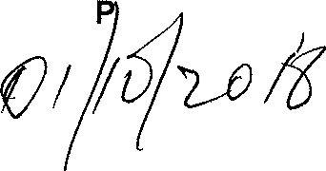
ER OF POLICE BH CELE, M

Date:

NATIONAL ASSEMBLY

FOR WRITTEN REPLY
PATE OF PUBLICATION IR INTERNAL QUE8TION PAPEg: 18 MAY 2018 (INTERNAL QUESTION PAPER NO 16-2018)
1S36. Mr C D Mataepe (DA) fo ask the Mlnlster of Pollca:
What number of (a) vehicles ara availabla for vlalble policing with specific ‹efe‹enm to eactor policing at the Be‹ffordview Police Station, (b) the epeclfled vehicles have mileage of (I) 1-100 000 kma, (li) 100 001-200 000 kms, tlll) 200 001-300 000 kms and (lv) over 300 000 kms and (c) day6 In 2017 was aach of the vehiclee out of working order7

REPLY:
NW1B78E

 | Number of  vehlalw  numbea) | (r) daya  out of  . order tbr ead vehlde, In 20J7 | Number of  vehlcles  numbers) | (o) days  out of  order fbr each vefilcl•, in 2017 | Number  of  (RAPS  numbers) | (c) daye  out of  order for aach vehJde, In 2047 | Numbar  of  (eAP9  numbers) | (c) daye.  out ef"!  order for., gach . .: vehlsk, In 201.7. .
 | BVG318B | 1 | BTY028B  BTL287B | 7  16 | BGY310B | 30 | Nil | NII
 |  |  | 8TD60be | 10

Orlgtnel aignod LIEUTENANT GEI4ERAL PROVINCIAL COMMI99IONER: GAUTEMG DB DE LANOE
Date: 22 May 2016

Reply to question 1536 recommended

’ATI L C

OUTH AFRICan›•ouce seRvlce

Date:
Reply to question 1536 approved/not approve‹I

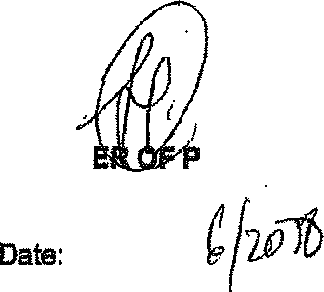
MINIST
OLfCE

