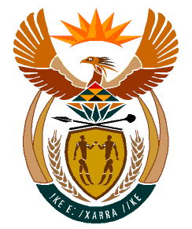

MINISTRY:
HUMAN SETTLEMENTS, WATER AND SANITATION
REPUBLIC OF SOUTH AFRICA

NATIONAL ASSEMBLY

QUESTION FOR WRITTEN REPLY

QUESTION NO.: 278

DATE OF PUBLICATION: 19 JULY 2019

Mr I S Seitlholo (DA) to ask the Minister of Human Settlements, Water and Sanitation:

What (a) total amount is budgeted for her private office for the 2019-20 financial year and (b) was the (i) total remuneration, (ii) salary level, (iii) job title, (iv) qualification and (v) job description of each employee appointed in her private office since 1 May 2019? NW1244E

REPLY:
(a) Honourable Member, there is no separate budget for the private office which is a component in the Ministry of Hunan Settlements, Water and Sanitation. My private office comprises of the Private Secretary, Assistant Private Secretary, Receptionist and two domestic workers.

(b) Conditions of employment such as salaries and qualifications of staff is confidential. The Protection of Personal Information Act and the Basic Conditions of Employment Act, amongst others, protect the confidentiality of such information.

However, I wish to indicate to the Honourable Member that Private Secretaries, Assistant Private Secretaries, receptionist in offices of Ministers share the responsibilities of managing the Ministers’ diaries, providing administrative support and protocol services as well as coordinating all the meetings between the two offices, i.e. Pretoria and Cape Town. The two domestic workers assist the Executive in their Cape Town and Pretoria residences.

