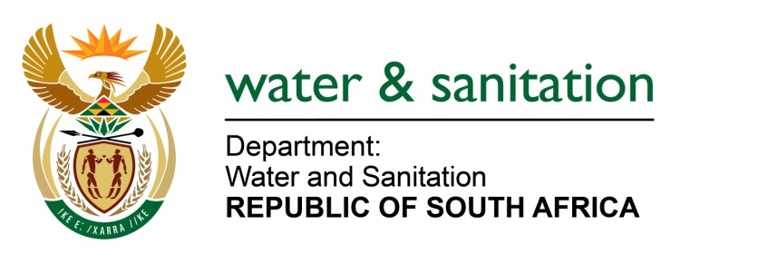

NATIONAL ASSEMBLY

FOR WRITTEN REPLY

QUESTION NO 2779

DATE OF PUBLICATION IN INTERNAL QUESTION PAPER: 2 SEPTEMBER 2022
(INTERNAL QUESTION PAPER NO. 29)

2779. Mrs C Phillips (DA) to ask the Minister of Water and Sanitation:

- What number of water use licences for (i) new iron ore and (ii) manganese mines and/or plants in the Northern Cape have been submitted since 2016 but have not yet been processed, (b) what are the names of the individuals and/or companies that applied for the licences and (c) where are/will the mines and/or plants be located?
NW3369E

---00O00--

MINISTER OF WATER AND SANITATION

There are two (2) Water Use Authorisations for Iron ore and Manganese mining activities currently in progress in the Northern Cape.

NO | APPLICANT | ACTIVITY | PROPERTY DETAILS | APPLICATION DATE | STATUS
1 | Vumaste Resources March | Iron ore and Manganese | Land Parcel 54 of the Major Region KURUMAN (Portion 0 of the Farm March 54IM), | 2022/08/24 | Finalising Assessment
2 | Japies Rus Minerale (Pty) Ltd | Iron ore and Manganese | Portion 1 of Land Parcel 668 | 2022/07/21 | Initial assessment

---00O00---

