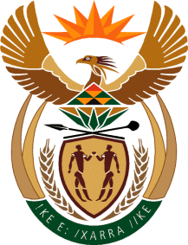

MINISTRY OF TOURISM
REPUBLIC OF SOUTH AFRICA

Private Bag X424, Pretoria, 0001, South Africa. Tel. (+27 12) 444 6780, Fax (+27 12) 444 7027
Private Bag X9154, Cape Town, 8000, South Africa. Tel. (+27 21) 469 5800, Fax: (+27 21) 465 3216

NATIONAL ASSEMBLY:

QUESTION FOR WRITTEN REPLY:
Question Number: 2779
Date of Publication: 20 November2020
NA IQP Number: 49
Date of reply: 05 November 2020

Mr M S F de Freitas (DA) to ask the Minister of Tourism:
With reference to the organisations supported by her department and/or SA Tourism in the past three financial years to date, on a monthly basis in each case, (a) what organisations are supported in any manner, irrespective of infrastructural support, financial support and/or any other type of support, (b) how are the specified organisations supported, (c) what is the value in Rands of support provided, (d) what are the reasons that the organisations are supported and (e) what benefit is there for her department in each case?
NW3603E

REPLY:

The Honorable member is referred to reply2148 dated 21 September 2020 where it was stated that the department does not support any organisations.
- – (e ) Not applicable

