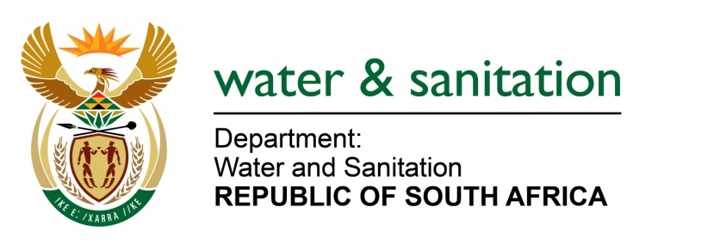

NATIONAL ASSEMBLY

FOR WRITTEN REPLY

QUESTION NO 2778

DATE OF PUBLICATION IN INTERNAL QUESTION PAPER: 2 SEPTEMBER 2022
(INTERNAL QUESTION PAPER NO. 29)

2778. Mrs C Phillips (DA) to ask the Minister of Water and Sanitation:

- What number of water use licences have been issued to existing iron ore and manganese mines and/or plants in the Northern Cape since 2016, (b) what are the names of the individuals and/or companies who hold the licences and (c) where are the mines and/or plants located?

NW3368E
---00O00---

MINISTER OF WATER AND SANITATION

- Twenty-one (21) licences are allocated to mining plants in the Northern Cape for iron ore (9), manganese (10) as well as manganese and iron ore (2) as indicated in the table below:

No | Name | Property | Activity | Date of issuance
1 | West coast resource (Pty) Ltd: Namaqualand Mine | Land Parcel Lang Klip 689 | iron ore | 2017-06-23
2 | Sishen Iron Ore Company (Pty) Ltd: Sishen Mine Operation HEF Plant | Lylyveld 545; Sekgamane 461; Woon 469; Sacha 468; Sims462 | iron ore | 2016-03-17
3 | Kudumane Manganese Resources (Pty) Ltd | Ptn 2 and 11 of Farm York A279 | manganese | 2016-05-29
4 | Hautian SA Mining and Investments (Pty) Ltd | Ptn 1 of Lemoteng 669 | manganese ore and iron ore | 2016-03-17
5 | Con-Ellen Pty Ltd | Land Parcel Kanguru 115 | iron ore | 2017-09-20
6 | Hondeklip Bay Mine (Pty) Ltd | Remainder of the Farm Richtersveld no. 11 portion 0 | manganese | 2018-01-16
7 | Sishen Ore Company (Pty) Ltd: Heuninigkranz & Langverwacht | Land Parcel Heuningkranz 364 | iron ore | 2018-05-17
8 | Kudumane Manganese Resources (Pty) Ltd | Portion 2 of farm York A279 | manganese | 2018-07-23
9 | Assmang (PTY) Ltd: Beeshoek Iron Ore Mine | Portion 4 of the Farm Olynfontein 475 | iron ore | 2018-08-21
10 | Kadgame Mining (Pty) Ltd | Portion 2 of the farm Kadgame 558 | manganese | 2018-11-19
11 | Northern Cape Mining Pty Ltd | Remaining extent of Lohatlha 673 | manganese | 2019-02-22
12 | Sishen Iron Ore Company (Pty) Ltd: Kolomela mine | Leeuwfontein 448, portion 0 (RE), Hay RD | iron ore | 2019-03-20
13 | Assmang Chrome: Black Rock Mine Operations | Portion 0 of the farm Belgravia 264 | manganese | 2019-04-10
14 | Sedex Desalination (Pty) Ltd | Land Parcel Strandfontein 559 | Iron ore | 2019-07-31
15 | Sebilo Resources (Pty) Ltd: Perth Manganese Mine | Remaining extent of portion 0 of the farm Perth 276 | iron ore | 2019-11-19
16 | Sishen Iron Ore Company (Pty) Ltd: Sishen Mine Operation | Sekgame 461 Remaining extent | iron ore | 2019-12-18
17 | Mokala Manganese (Pty) Ltd | Land Parcel Gloria 266 of the Major Region KURUMAN | manganese | 2020-08-14
18 | Tshipi e Ntle Manganese Mining (Pty) Ltd: Tshipi Borwa Mine | Portion 8 of the farm Mamatwana 331 | manganese | 2020-11-05
19 | Sitatunga East Manganese (Pty)Ltd | Remaining Extent of Farm East no.270, Kuruman | manganese | 2022-03-11
20 | Aquila Steel (S Africa) Pty Ltd | Farm Gravenhage 703, Portion114 | manganese | 2022-06-30
21 | Black Mountain | Portion 1 Sand Kolkjes No.194 | prospecting diamonds, manganese, iron, nickel | 2022-06-30

---00O00---

