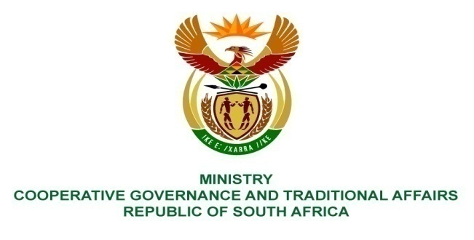
__________________________________________________________
FOR WRITTEN REPLY
NATIONAL ASSEMBLY
PARLIAMENTARY QUESTION 2778

Mr H B Groenewald (DA) to ask the Minister of Cooperative Governance and Traditional Affairs:
What amount did the Ekurhuleni Metropolitan Municipality (a) budget and (b) spend in the upgrading of the stormwater system in the (i) 2014-15, (ii) 2015-16 and (iii) 2016-17 financial years?

REPLY:
The following information was provided by the Ekhurhuleni Metropolitan Municipality:
(a) The municipality originally budgeted (i) R 10,00 million in 2014-15, (ii) R 5,50 million in 2015-16 and (iii) R 8,00 million in 2016-17 financial years, for the upgrading of the stormwater system.
The annual budgets were subsequently adjusted to (i) R 10,00 million in 2014-15, (ii) R 11,50 million in 2015-16 and (iii) R 8,70 million in 2016-17 financial years.

(b) The municipality spent (i) R 1,36 million in 2014-15, (ii) R 8,07 million in 2015-16 and (iii) R 8,38 million in 2016-17 financial years.

