

**MINISTRY**

**STATE SECURITY**

**REPUBLIC OF SOUTH AFRICA**

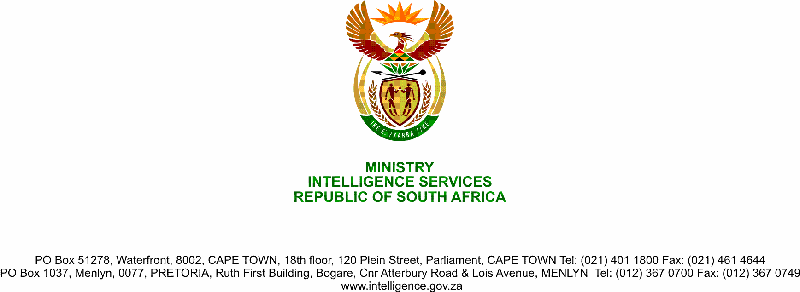

**NATIONAL ASSEMBLY**

**QUESTION FOR WRITTEN REPLY**

**QUESTION NO.:** **2775.**

**Ms T L Marawu (ATM) to ask the Minister of State Security:**

Given the growing influence of the Islamic State of Iraq and Syria (ISIS) that has spread from Tanzania to Mozambique where innocent citizens were beheaded recently, what (a) is the likelihood that ISIS is already operating in the Republic and (b) steps has her department taken to thwart such a threat? NW3594E

**REPLY**

This Parliamentary question deal with sensitive State Security Agency operational issues, of which Joint Standing Committee on Intelligence (JSCI) in Parliament has been created to deal with. Accordinly, reply to this parliamentary question has been submitted to the Parliament’s Joint Standing Committee on Intelligence (JSCI).