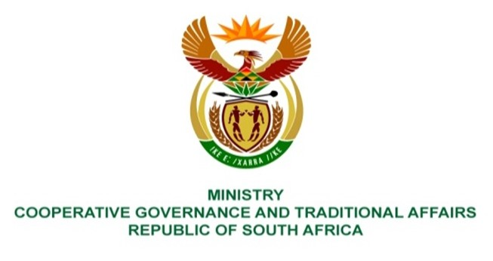

NATIONAL ASSEMBLY
QUESTION FOR WRITTEN REPLY

QUESTION NUMBER 2772
DATE OF PUBLICATION: 02 SEPTEMBER 2022

QUESTION:

2772. Mr D Joseph (DA) to ask the Minister of Cooperative Governance and Traditional Affairs:
Whether she will use the (a) findings and (b) recommendations of the report of the Judicial Commission of Inquiry into Allegations of State Capture, Corruption and Fraud in the Public Sector including Organs of State to investigate if her department and/or the entities reporting to her contributed towards state capture; if not, why not; if so, (a) which part of the report is relevant to her department and (b) on what date will the investigation start? NW3359E

REPLY:

(a) and (b) No, the Minister of Cooperative Governance and Traditional Affairs (COGTA) will not use the Report on the Judicial Commission of Inquiry into Allegation of State Capture to investigate whether the Departments and/or Entities reporting to her contributed towards state capture.

- On reading the various reports, there is an indication that there are no parts of the report that are relevant to the Departments and Entities reporting to the Minister of COGTA. Although, there are certain issues affecting a municipality that were highlighted in the report, there are no specific findings and/or recommendations in relation to the affected municipality. Officials from the Department have collaborated with officials from the Department of Planning, Monitoring and Evaluation (DPME) to assess all the recommendations emanating from the various reports of the Commission. Should this broader assessment in collaboration with the DPME identify matters that require my attention, I will ensure that the necessary steps are taken, especially where legislative or institutional changes would be required and prepare motivated implementation plans, indicating how each recommendation ought to be addressed.
(b) Not applicable.

