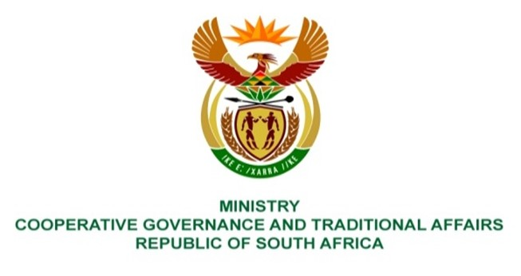
NATIONAL ASSEMBLY
QUESTION FOR WRITTEN REPLY
QUESTION NUMBER: 2771

2771. Mr D Joseph (DA) to ask the Minister of Cooperative Governance and Traditional Affairs:
QUESTION:

- Whether she has found that the latest annual report of the Auditor-General which reflects on poor service delivery performance of the majority of municipalities is a sign of a failed State; if not, what is the position in this regard; if so, what are the relevant details.
- What plans will her departments introduce to improve the constitutional mandate of local government.
- Whether the specified plans will include consequence management, if not, why not, if so, what are the relevant details?

REPLY:

- No.

- The Department of Cooperative Governance (DCoG) has presented the reviewed State of Local Government Report and has facilitated the drafting of Municipal Support and Intervention Plans (MSIPs) in collaboration with key sector departments (Water and Sanitation, Human Settlements, Energy, Environment), the South African Local Government Association (SALGA), provincial COGTAs and municipalities. The DCoG through the Municipal Infrastructure Support Agent (MISA) continues to strengthen the capacity of municipalities by providing technical support on infrastructure development and service delivery through deploying 73 professionally registered built environment officials to municipalities across the country. Additional programmes implemented to support municipalities include Recognition of Prior Learning (RPL) for artisans, water and wastewater process controllers and other technical training courses, partnerships with institutions of higher learning to provide much needed skills at local government.

- The prerogative to institute consequence management vests in the Municipal Councils. The following legal instruments have been put in place to enable municipal councils to fulfil their constitutional obligations:

1) Disciplinary Regulations for Senior Managers, 2011,
2) Municipal Regulations on Financial Misconduct Procedures and Criminal Proceedings, 2014 and
3) The Disciplinary Procedure Collective Agreement for staff below management echelon, 2018.

