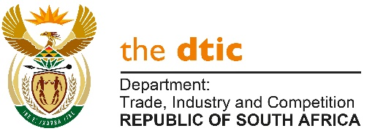

THE NATIONAL ASSEMBLY

QUESTION FOR WRITTEN REPLY

QUESTION NO. 277

DATE PUBLISHED: 17 FEBRUARY 2023

Mr Z N Mbhele (DA) to ask the Minister of Trade, Industry and Competition:

(1) Whether, with reference to his reply to question 2269 on 4 October 2021 and his speech in his Budget Vote on 20 May 2022, the Draft Patents Amendment Bill, which will have a far-reaching impact on the Republic’s pandemic readiness and the local manufacturing of medicines, therapeutics and diagnostics, was submitted to Cabinet for consideration by October 2022 as announced; if not, (a) why not, (b) on what date will it be submitted to Cabinet and (c) on what date will the Cabinet consideration process be completed; if so, on what date was it submitted;
(2) Whether the Cabinet has finalised its consideration of the Bill; if not, what is the position in this regard; if so, on what date will the Bill be released for public comment? NW284E

REPLY

During the dtic Budget Vote in May 2022, I advised that the dtic completed comprehensive work on a draft Patents Bill (PB) to be submitted to Parliament after consideration by Cabinet. The aim of the draft Bill is to update and reform SA’s patent legislation by synchronizing the legislation with international developments.

The draft Bill was indeed subsequently completed.

Following the Budget Vote debate however, further consultations were required to take account of two additional developments:

First, the final agreement reached at the World Trade Organisation (WTO) on waivers and flexibilities relating to pandemic use of patented vaccines, contained a provision to conclude discussion on therapeutics and diagnostics with an extended timeframe. This follows a request from developed countries for such facility; and

Second, discussions that took place during the latter half of 2022 at the African Union, through the Council of Ministers responsible for the AfCFTA, on a Protocol on Intellectual Property Rights, which was formally reported to at the African Union Assembly during February 2023.

Both these international agreements may impact on the contents of the Bill.

As soon as the implications of these two developments have been considered, the final version will be submitted to Cabinet.

-END-

