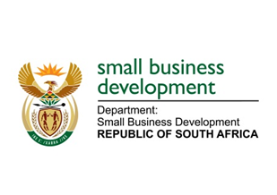
National Assembly
QUESTIONS FOR WRITTEN REPLY

277. Mr Z N Mbhele (DA) to ask the Minister of Small Business Development:
(a)(i) What total amount in funding was approved by the Small Business and Innovation Fund by the end of December 2019 and (ii) to what number of small and medium enterprises was such funding allocated and (b) what is the (i) provincial and (ii) business sector breakdown of the approved beneficiaries?
NW365E

REPLY:

- i) Total SBIF approvals by December 2019 stood at R225 million
ii) This amount was approved under sefa’s SME Wholesale Lending channel, which is executed through intermediaries. The amount disbursed will be available by the end of April 2020 from sefa’s intermediary partners. The abovementioned information will provide developmental statistics relating to the number of SMMEs funded, the provincial spread as well as the amounts disbursed. Once received, this information will be shared accordingly.

