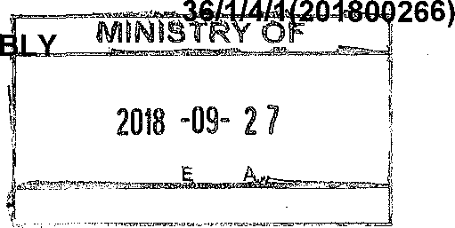
NATIONAL ASSEM

FOR WRITTEN REPLY QUESTION 2766
DATE OF PUBLICATION IN INTERNAL QUESTION PAPER: 14 SEPTEMBER 2018 (INTERNAL QUESTION PAPER NO 30-2018)

2766. Ms D Kohler (DA) to ask the Nlinister of Police:
- Whether, with reference to the Second-Hand Goods Act, Act 6 of 2009, (a) each police station has dedicated officers who visit (a) second-hand goods stores and (b) scrap metal dealers to check that they are taking identity document numbers;

- ha\ie the regulations according to the specified Act been completed in each case; if not, why not; if so, on what date?
NW3059E
REPLY:

(1)(a)(b) Designated Police Officers (DPOs) are appointed at police stations, to conduct compliance inspections in terms of the Second-Hand Goods Act, 2009 (Act No 6 of 2009). This includes registered second-hand goods stores and scrap metal dealers. However, at most police stations, the appointed DPO is also responsible to conduct compliance inspections, in respect of the firearm and liquor environments.

As part of the compliance inspection, all records maintained by the registered second-hand goods dealer, are checked by the DPO to ensure that they are taking identity document numbers. The compliance inspection includes the verification of copies of the applicable official document, as proof of the identity of the person, who either acquired or disposed of goods, as prescribed in Sections 21(4) and (5) of the Second- Hand Goods Act. The proof of identity can be a temporary South African identity certificate, a South African identity document, a valid current passport or a valid current South African driving licence.

(2) Yes, the regulations, as required in terms of Section 41 of the Second- Hand Goods Act, for the accreditation of Second-Hand Goods Dealers

2

Associations was completed and promulgated on 6 September 2011, in the Government Notice, No R703. The Regulations for Dealers and Recyclers was completed and promulgated, on 3 April 2012, in the Government Notice, No R285.

Reply to question 2766 recommended

Date:

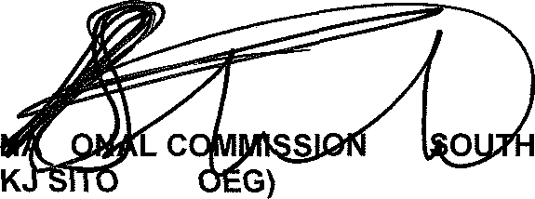
26J8 -I?- 2 6
TI
ER:
LE (S
GENERAL AFRICAN POLICE SERVICE

Reply to question 2766 approved
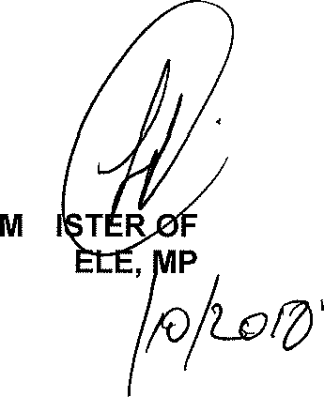
IN BH C
POLICE
Date: /

