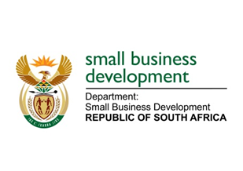
NATIONAL ASSEMBLY
QUESTION FOR WRITTEN REPLY

“2762. Mr J N de Villiers (DA) to ask the Minister of Small Business Development:
What total amount has her department spent on external consultants in the period 1 May 2019 to 31 May 2022?” NW3346E

REPLY: I have been advised by the department as follows:

The Department of Small Business Development (DSBD) spent a total of R4 512 571.93 on consultants from 1 May 2019 to 31 May 2022, as tabulated below:
DSBD Consultants services - 1 May 2019 to 31 May 2022
Item | Purpose | Amount in Rands
Audit committee | - Audit related functions | 773 254,15
HRM services | - Employee, Health and Wellness related matters | 307 570,81
Occupational health | - Training | 7 900,00
Organisational structure | - BBBEE Verification | 54 625,00
Qualification verification | - Payment for candidate verification | 146 980,38
Research and advisory | - Appointment of a service provider to provide an overview of the economic challenges experienced by SMME's cooperatives in South Africa and a comparative analysis of policy responses of at least three (3) countries at a similar stage of development and propose suitable policy responses to DSBD for a period of six (6) months.  - Appointment of a service provider to undertake a study on an analysis and assessment of barriers to entry for small, macro and medium enterprise and cooperatives to economic opportunities and to draft a policy framework.  - Update the IDBS Policy and Package for Gazzette.  - Appointment of a service provider to assist the Department with the strengthening of the Red Tape Reduction strategy.  - SMME Annual Review.  - Financial Literature and Context Review.  - Provision of human resources within the Office of the Director-General to render Secretariat functions for a period of 12 months. | 3 118 601,60
Translate and transcription | - Interpretation and sign language services | 103 639,99
TOTAL |  | 4 512 571,93

STELLA NDABENI-ABRAHAMS
MINISTER: SMALL BUSINESS DEVELOMENT

