FORWRlTTENREPLY

QUESTION 2759

NATIONAL ASSEM +
36/1/4/1(2018)

DATE OF PUBLICATION IN INTERNAL QUESTION PAPER: 14 SEPTEMBER 2018 (INTERNAL QUESTION PAPER NO 30-2018)

2759. Mr D Bergman (DA) to ask the Minister of Police:

- What is the total number of (a) A-class reservists and (b) D-class reservists who were in serVice in the SA Police Service on (i) 31 May 2012 and (ii) 31 May 2018;

what total number of the reservists who left had to leave because they were not able to do firearm competency tests;

- what is the total number of the D-class reservists who ha\ie been converted to A-class reservists between 31 May 2012 and 31 May 2018?
NW3052E
REPLY:
(1) a) Number of A-Class Reservists on -' i) 31 May 2012: 17 939
ii) 31 May 2018: 3 002

b) Number of D-Class Reservists on

 | i) | 31 May 2012: | 32 524
(2) | ii)  None. | 31 May 2018: | 4 087

FOR WRITTEN' REPLY

QUESTION 2759

DATE OF PUBLICATION IN INTERNAL QUESTION PAPER: 14 SEPTEMBER 2018 (INTERNAL QUESTION PAPER NO 30-2018)

(3) During 2014, a new National Instruction 3/2014: The Reserve Police Service was approved by the National Commissioner which regulates the Reservists dispensation in the South African Police Service. In terms of National Instruction 3/2014, the categories of A Reservist, B Reservist, C Reservist and D Reservist was abolished and replaced with Category 1: Functional Police and Category 2: Specialised Operational Support. As on 17 September 2018, there are 3762 Category 1 Reservists and 40 Category 2 Reservists in the South African Police Service. The process of converting the remaining A, B, C and D category Reservists to Category 1 and Category 2 are in process.

L TSHIEA
Date: \& ! '='9
LIEUTENANT GENERAL PERSONNEL MANAGEMENT

Reply to question 2759 recommended/

DEP
BC MGWENY
Date: \

LIEUTENANT GENERAL COMMISSIONER: HUMAN RESOURCE MANAGEMENT

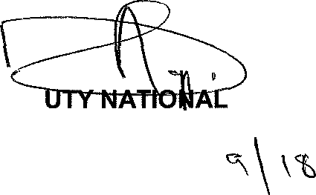
Reply to question 2759 recommended

GENERAL IS SO TH AFRICAN POLICE SERVICE
ROLE (SOEG

FOR WRITTEN REPLY

QUESTION 2759

DATE OF PUBLICATION IN INTERNAL QUESTION PAPER: 14 SEPTEMBER 2018 (INTERNAL QUESTION PAPER NO 30-2018)

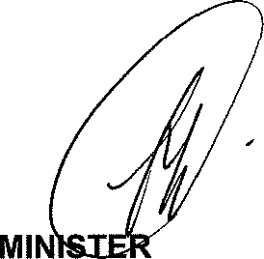
Reply to question 2759 approved/we

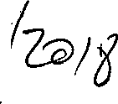
OF POLICE BH CELE, P
Date: @/

