FOR WRITTEN REPLY

NATIONAL ASSEMBLY
36/1/4/1(201900024)

QUESTION 264

DATE OF PUBLICATION IN INTERNAL QUESTION PAPER: 15 FEBRUARY 2019 (INTERNAL QUESTION PAPER NO 2-2019)

264. Mr N S Matiase (EFF) to ask the Minister of Police:

What number of (a) tender briefings were held in 2018 by (i) his department and (ii) each of the entities reporting to him and (b) the specified briefings were compulsory?
NW275E
REPLY:

(a)(i) A total of 65 tender briefing sessions were held in 2018 by the South African Police Service's Supply Chain Management Division.
(a)(ii) To be responded to by the other entities who report to the Minister.
(b) A total of 63 tender briefing sessions were compulsory.

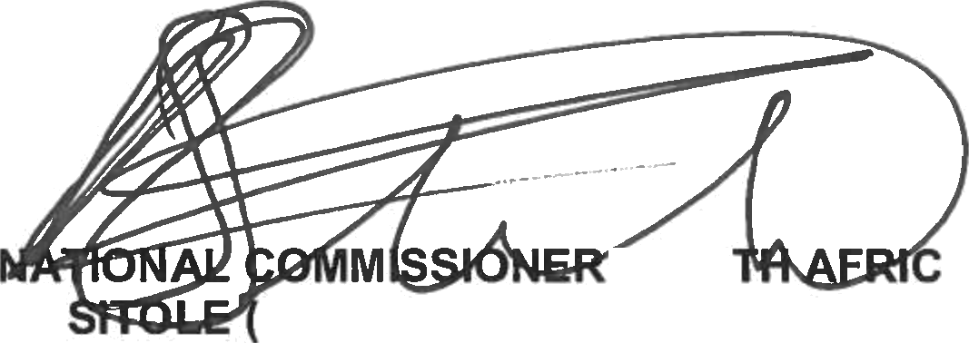
Reply to question 264 recommended/ein

KJ SOEG)
Reply to question 264 approved/not approved

MINISTER OF POLICE BH CELE, MP

Date:

GENERAL AN POLICE SERVICE

