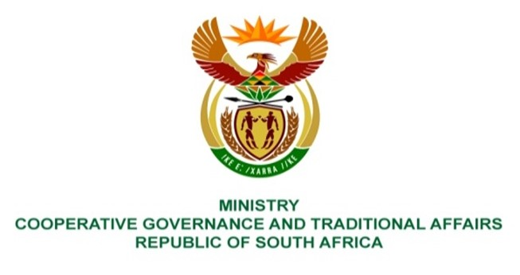

NATIONAL ASSEMBLY
QUESTION FOR WRITTEN REPLY

QUESTION NUMBER 2737
DATE OF PUBLICATION: 02 SEPTEMBER 2022

QUESTION:

2737. Mr I M Groenewald (FF Plus) to ask the Minister of Cooperative Governance and Traditional Affairs:
- Whether, with reference to section 57A(1) and (2) (details furnished) of the Local Government: Municipal Systems Act, Act 32 of 2000, as amended, she has yet to determine the different periods for the different categories of misconduct; if not, (a) why not and (b) by what date does she intend to prescribe the different categories as required by the specified Act; if so, what are the relevant details;
- whether she will make a statement on the matter? NW3313E

REPLY:
1. No. The President of the Republic of South Africa assented to the Local Government: Municipal Systems Amendment Act No. 3 of 2022 on 17 August 2022 which Act will be operational on 1 November 2022. New regulations relating to this matter will be finalised and gazzeted in due course.

2. The Minister of COGTA will not make a statement on the matter.

