FOR §¥RI EN REPLY

NATIONAL ASSEMBLY
36/1/4/1(2021)

2734. Mr A G Whitfield (DA) to ask the Minister of Police:
- With reference to his reply to question 1317 on 8 September 2021 regarding CAS 151/02/2020 related to the Athlone Pollce Station and FEiCOfd9 that he provided, on what date dld a ceñain person (name furnished) become aware of allegations that a certain person (name also furnished) and officers under his command were implicated in an assault a certain person (name furnished); if so, on what date;

- whether, upon becoming aware, the specified parson and/or any another member of the SA Police Service management (a) placed the specified person and/or or any member on precautionary 9uspension and/or desk duty and/or (b) initialed a departmental investigation; if not, why not; if so, what was the outcome and/or recommendation;

- whether a certain person (name furnished) is still employed in SAPS today; if not, (a) on what date and (b) how was his employment termlnated; if so, what are the relevant details?

REPLY:
NW3249E

(1) Lieutenant Colonel Nicholas, the Acting Station Commander of the Athlone Police Station, became aware of the death of Adam Isaacs, on 27 January 2020. Colonel Adonis, tha Station Commander, returned from leave, on 3 February 2020.

(2)(a) No member was placed on pmcautionary suspension and/or desk duty.

(2)(b) No departmental investigation was initiated at the time. Subsequently, two disciplinary investigations have been initiated into the members’ alleged involvement in the death, as per DR 05/2021 and the police station managements’ failure to act, as per DR 55/2021. The disciplinary investigation is pending finalisation. The criminal case was referred to the Independent Police Investigativr• Directorate (IPID) and is still under investigation.

(3)(a) Yes, tha member Is still employed in the South African Police Service (SAPS).

(3gb) Not applicable.

Reply to question 2734 recommended

OM E(SOE
Date: j$$1 -1/- **

GENERAL AFRICAN POLICE SERVICE

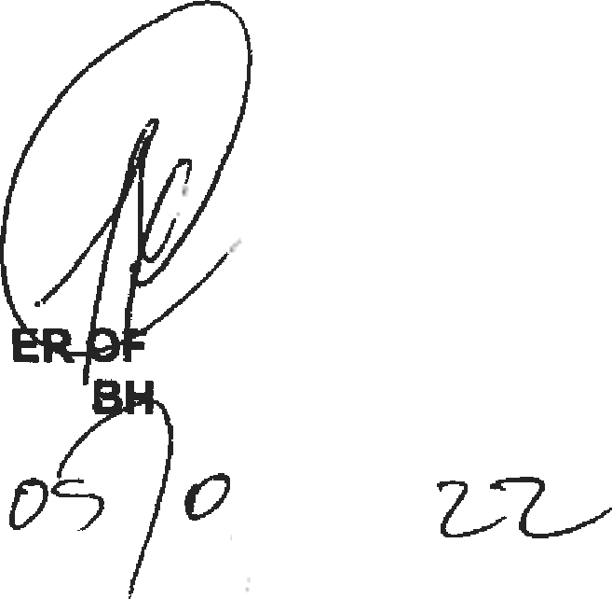Reply to question 2754 approved/not

MINIST POLICE
GENERAL CE MP

Date:

