FOR ?¥RITTE {TEPLY

NAYIONAL ASSENBLY
38/1/4/1(2021}

2733. Mr A G Whitfield (DA) to ask the Minister of Police:

- With reference to the printing of firearms licences, (a) what is the (i) nature and (li) value of the contract between the SA Police Service (SAPS) and the Government Printing Works (GPW) and (b) number of firearm licences that havo been printed in each quarter (i) in the (aa) 2019-20 and (bb) 2020-21 financial years and (ii) since 1 April 2021;

- whether there kas been any contractual dispute between SAPS and the GPW during the specified period which has negatively affected the printing of licences; if not, what is the pos"8ion in this regard; if so, what are the relevant detalls?

REPLY: (1)(a)(i)

(1)(a)(ii)

(1)(b)(i)(aa)(bb)(ii)
NW3248E

Tha nature of the contract is the supply, printing and distribution of printed firearm licence and related cards.

The value of the contract, was R62 314 716,76. The contract wac signed, on 10 November 2017 and explred, on 9 November 2020. It was extended, on 9 November 2020 to 9 May 2021 and further extended, until B November 2021. Currently there is no valid contract in place. An approval was granted for the Government Printing Works {GPW) to continue printing firearm licence cards, on a once-oP quotation basis, until 30 November 2021. An application, for an additional three month extension period, has been submitted and is awaiting approval. A contract will be in place, once the internal processes, have baen finalised.

Tha number of firearm licences that have been printed in each quarter in the 2019-2020 and 2020-2021 financial years and since 1 April 2021, is reflecte‹I in the table below.

2

Quarter Month | 2019/2020 |  | 2020/2021 | Z021/2022  /1 April 2021 to 7 December 202f]
Quarter 1 | 23 107 |  | The GPW  was c/osad,  COVID-19. | 7 468
 | 12 723  13 030 |  |  | 24 124
 |  |  |  | 35 830
Quarter 2 ust  tember | 14 334 |  | 29 170 | 8 852
 | "17 610 |  | 12 652 "” | 26 982  13 340
 | 11 959 |  | 11 557
October  Quarter 3 November  December | 13 557 |  | 8 826 | 20 246
 |  | 13 598 | 10 187 | " 6 403
 |  | 8 369 | 15 579 | 29 196
Janua  Quarter 4 Februa  _ March “  ’Total | 13 382 |  | 4 464
 | 10 895 |  | 22 118
 | ""”"

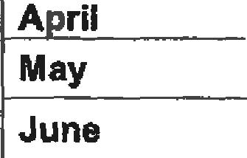(2) There have been no known contractual disputes between the South African Police Service (SAPS) and the GPW, which negatively affected the printing of licences. The GPW is printing firearm licence cards, on behalf of the SAPS.

Reply to question 2733 recommended

(SOE

Date. (gj -g- $ §
Reply tu question 2733 approved/ ot
GENERAL AFRICAN POLICE SERVICE

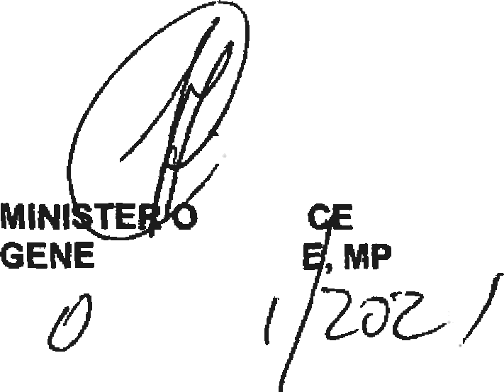

F POL!
RA CEL

