MEMORANDUM FROM THE PARLIAMENTARY OFFICE
NATIONAL ASSEMBLY
FOR WRITTEN REPLY
QUESTION 2732
DATE OF PUBLICATION OF INTERNAL QUESTION PAPER: 2/09/2022
INTERNAL QUESTION PAPER NO 29 OF 2022
Mrs N I Tarabella Marchesi (DA) to ask the Minister of Higher Education, Science and Innovation: [ê456] [Question submitted for oral reply now placed for written reply because it is in excess of quota (Rule 137(8))]:
Whether, with reference to a surge in the number of calls received by the SA Depression and Anxiety Group from students who are experiencing mental health challenges in relation to the disruptions caused by the COVID-19 pandemic, and in view of the shocking number of student suicides that are witnessed in the Republic, his department has taken any steps to capacitate institutions of higher learning to deal with the crises; if not, why not; if so, what are the relevant details in each case? NW3301E

REPLY:
The Department acknowledges the surge in the number of students who are experiencing mental health challenges, especially in relation to the disruptions caused by the COVID-19 pandemic, as well as the number of student suicides that are reported. The Department regards addressing mental health is part of a holistic approach to the health and wellbeing of staff and students. Therefore, the Department is funding HIGHER HEALTH to the tune of R20,604 million (2022/3); R27,530 million (2023/4); R28,440 million (2024/5) and R29,714 million (2025/6) to implement a comprehensive and integrated programme promoting health and well-being of students and staff additional to the allocated budget in the baseline for each institution.
HIGHER HEALTH is the implementation arm of the Department to implement a comprehensive and integrated programme promoting health and wellbeing of students across South Africa’s public universities and TVET colleges and provide on-campus support to PSET institutions in 7 priority areas:
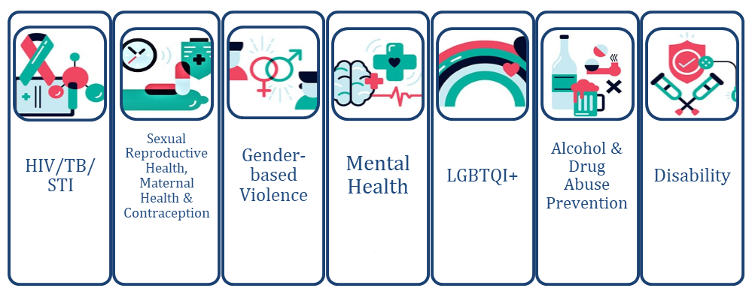
Mental Health, as seen in the diagram is central to the approach. HIGHER HEALTH is skilled in facilitating both first and second curriculum activities in the form of peer-to-peer education and in-classroom interventions through the integration of general health and wellness, addressing the wide range of social and health challenges experienced by staff and students. It is done at all campuses of universities and TVET colleges.
HIGHER HEALTH provides psycho-social support services through several means, including: (1) pro-active screening; (2) prevention and awareness programmes (3) organised programmes such as first-thing-first and second curriculum activities (4) the HIGHER HEALTH toll-free helpline, and (2) through interventions provided by on-campus and off-campus counselling and clinical psychologists. HIGHER HEALTH's activities also include focussed campus activities, campus radio programmes and peer support mechanisms. HIGHER HEALTH has set up campus and community radio stations to engage young students routinely on matters related to specific Sexual and Gender Based Violence and mental health as a matter of priority. There is also HIGHER HEALTH's 24-hour toll-free helpline available in all 11 official languages. The line offers health, wellness and psychosocial risk assessment toolkits for early screening, empowerment and referral related to gender-based violence, mental health, HIV, TB and other matters.
This year, over 14 000 students accessed the various HIGHER HEALTH models of psychosocial support. Academic stress and anxiety (30%), general stress and substance abuse (22%) depression and suicide (18%) and sexual, physical and emotional abuse (19%) present the main reasons for accessing support care. The Honourable Member also asked what are the relevant details in each case. Information on individual reported cases are captured by institutions and HIGHER HEALTH, and reported in aggregated form to the Department's University Branch. Information on each case is confidential and cannot be shared.
INSTITUTIONAL INITIATIVES
All universities and TVET Colleges have measures in place to raise awareness, offer guidance and advice and support students and staff through Campus Services and Student Support Services. These include, but are not limited to: workshops or presentations during orientation weeks and during various parts of the year for students; roadshows; training; production and dissemination of brochures and other literature for the university community; and information on institutional websites.
The Department plays an oversight role, monitoring institutions to ensure that institutions take full responsibility for addressing health and well-being of students and staff on their campuses.

