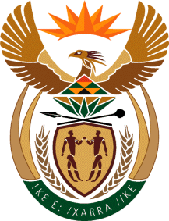
MINISTRY
SPORT AND RECREATION
REPUBLIC OF SOUTH AFRICA

Department of Sport and Recreation l Private Bag X896 l PRETORIA l 0001 l Regent Place l 66 Queen Street l Pretoria l 0001 l +27 (0)12 304 5158 l Fax: +27 (0)12 323 8426
Private Bag X9149 l Cape Town l 8000 l 2nd Floor Parliament Building l 120 Plain Street l CAPE TOWN l Tel: +27 21 469 5705 l Fax: +27 21 465 4402
www.srsa.gov.za
_____________________________________________________________________

NATIONAL ASSEMBLY

WRITTEN REPLY

QUESTION PAPER: No. 32 of 08 SEPTEMBER 2017

DATE OF REPLY: 10 OCTOBER 2017

2732. Mr T W Mhlongo (DA) asked the Minister of Sport and Recreation:
(1) Whether he accompanied the national football squad, Bafana Bafana, for their match against Cape Verde on 2 September 2017; if so (a) what was the reason for this, (b) who paid for the (i) travel costs and (ii) accommodation costs;

(2) whether any other costs were incurred on this trip; if so, who will pay for these costs? NW3039E
______________________________________________________________________
The Minister of Sport and Recreation

REPLY:

(1) Yes.
(a) The Minister was invited by the South African Football Association (SAFA) to accompany the national senior men’s football team (Bafana Bafana), as the team was to play in a crucial FIFA World Cup qualifiying match against Cape Verde.

(b) (i) and (ii) The traveling costs for the Minister were borne by SAFA.

(2) The only other cost of the trip was subsistence allowance, which was covered by the Department of Sport and Receation South Africa.

