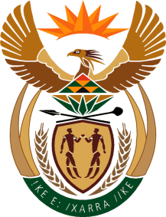

MINISTRY OF TOURISM
REPUBLIC OF SOUTH AFRICA

Private Bag X424, Pretoria, 0001, South Africa. Tel. (+27 12) 444 6780, Fax (+27 12) 444 7027
Private Bag X9154, Cape Town, 8000, South Africa. Tel. (+27 21) 469 5800, Fax: (+27 21) 465 3216

Ref: TM 2/1/1/10

NATIONAL ASSEMBLY:

QUESTION FOR WRITTEN REPLY:
Question Number: 273
Date of Publication: 24 February 2017
NA IQP Number: 4
Date of reply: 3 March 2017

Mr J Vos (DA) to ask the Minister of Tourism:

What are the full relevant details of the engagements between his department and the Department of Environmental Affairs to make access to national and provincial parks more affordable for South African citizens? NW291E

Reply:

The department has a Memorandum of Understanding (MOU) with the Department of Environmental Affairs to co-operate in different areas that support the development and growth of tourism.

The department has been engaging with SANParks regarding discounted rates for specific groups and these have been included in the social tourism directory, which is distributed to NGOs, schools and Stockvels.

In addition, annually the parks continue to host open parks week during tourism month as part of promoting inclusive participation, targeting surrounding communities and South Africans broadly.

Provincial parks are under the control of their respective provincial authorities.

