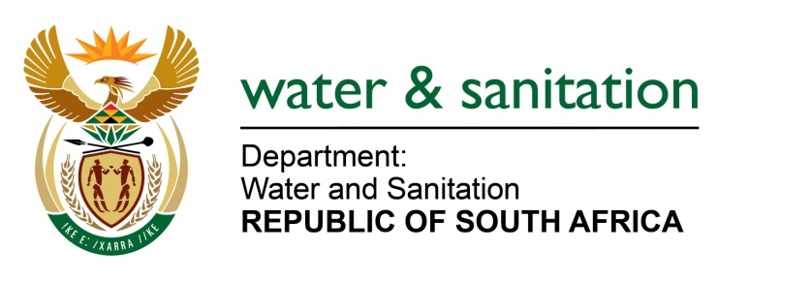

NATIONAL ASSEMBLY

FOR WRITTEN REPLY

QUESTION NO 2727

DATE OF PUBLICATION IN INTERNAL QUESTION PAPER: 31 JULY 2015
(INTERNAL QUESTION PAPER NO. 26)

2727. Ms T E Baker (DA) to ask the Minister of Water and Sanitation:
(1) What (a) amount has been spent on the project to raise the Hazelmere Dam wall to date and (b) are the relevant details of the expenditure;
(2) what (a) was the annual percentage increase in sedimentation of the Hazelmere Dam over the past five years, (b) impact has this had on the storage capacity of the dam and (c) are the causes of the increased sedimentation;
(3) whether any action has been taken to reduce and halt further sedimentation of the dam in future; if not, why not; if so, what are the relevant details? NW3158E
---00O00---

REPLY
(1)(a) The total amount spent to end July 2015 is R41 713 943 (excl. VAT).
(1)(b) The relevant detail of expenditure is as follows:
DESCRIPTION | EXPENDITURE TO END JULY 2015  (excl. VAT)
ENVIRONMENTAL | R 399 319
LAND MATTERS | R 11 815 024
DESIGN AND SUPERVISION | R 23 216 748
CONSTRUCTION
- Dam | R 0
- Demolition of Buildings | R 6 282 853
TOTAL (excl. VAT) | R 41 713 943
(2)(a) The Hazelmere Dam has indicated an average of 0.72% increase in sedimentation over a 36 year period.
(2)(b) The storage capacity has been reduced from 23,94 million m³ to 17,675 million m³
(2)(c) Increased erosion in the catchment combined with increased sand-mining activities.
(3) Unlawful water uses through sand mining activities that contribute to sedimentation have been investigated on the Mdloti River upstream and downstream of the dam; and enforcement actions taken. A Catchment Management Forum also exists to deal with issues and concerns raised by water users within the catchment.
---00O00---

