FOR WRITTEN REPLY
QUESTION 2723

NATIONAL ASSEMBLY
3g/1/4f1(2021)

DATE OF PUBLICATION IN INTERNAL QUESTION PAPER. 3 DEC gIBER. 2021 (INTERNAL QUESTION PAPER NO 31-2021)

2723. Dr N V Khumalo (DA) to ast‹ the Minister of Police:

Whether, with reference to the increase in the crime rate in the Republic, there are currently any collaborative interventions undertaken by the SA Police Service and the Department of Basic Education to deal with the (a) violence in schools amongst learners and (b) kidnapping of children in 9chools; if not, why not; if so, (i) what has been the method of measuring the impact of the interventions and (ii) to what extent has he found this to a reflection of an ineffective national intelligence function?
NW3237E

REPLY:
(s) The South African Police Service (SAPS) and the Department of Basic Education (DBE) have completed the process of reviewing the School Safety Protocol, which guides the implementation of School Safety Programmes, aimed at promoting safer schools, nationally. There are various crime
awareness campaigns, which are implemented and conducted, by the SAPS, at schools to address, amongst others, incidences of bullying and gangsterism amongst learners, in and around school premises. Currently there is a National School Safety Violence and Bullying Prevention Initiative that is being implemented, in response to the emerging incidents of bullying and violence by learners on and off school premises.

The SAPS also has a flagship project called the Junior Commissioner Project, whicF‹ is being implemented, from Grades 8 to 12. Junior Commissioners are appointed in schools, to lead crime prevention campaigns, under the mentorship of the SAPS. Junior Commissioners are also participating in School Safety Committees in their areas.

- Awareness campaigns, which focus on the kidnapping of leaners to and from schools, are conducted, on an ongoing basis. Multidisciplinary Investigation Teams have been established in the hotspot provinces, namely Gauteng,

KwaZulu-Natai, the Western Cape, North West and Limpopo. These teams are part of the Provincial Organised Crime Investigation units. Cases are prioritised, centralised and investigated, in terms of the 72-Hour Activation Plan. The Provincial Organised Cfime Investigation teams are coordinated by the National Organised Crime Investigation Unit and activated by the Joint Operational Centres (JOC) and consist of:
  - Hostage negotiators.
  - Crime intelligence.
  - Detective Service (local police station).
  - Organised Crime units (National and Provincial levels).
  - Forensic Services, including Crime Scene Management.
  - Tactical Response Teams.

For the investigation of kidnapping cases, the multidisciplinary teams, make use of the following:
u Arrest of identified persons.
  - Centralisation of case dockets, for investigation purposes.
  - Centralisation of case dockets, for trial in court and prosecutor-directed investigations with the National Prosecution Authority (NPA).
  - Collection and analysis of data and information received, on the cases that are investigated by the multidisciplinary teams. This intervention has resulted in a decrease of the kidnapping of school children.

(i) The impact of the intervention programmes is measured through ongoing compliance inspections. Capacity building sessions are done where a gap is identified with regard to the implementation of School Safety Programmes.

(ij
The involvement of the National Crime Intelligence does yield positive results, which assists investigation teams in effecting arrests and aeizures, as well as the confiscation of valuable exhibits during track and trace operations.

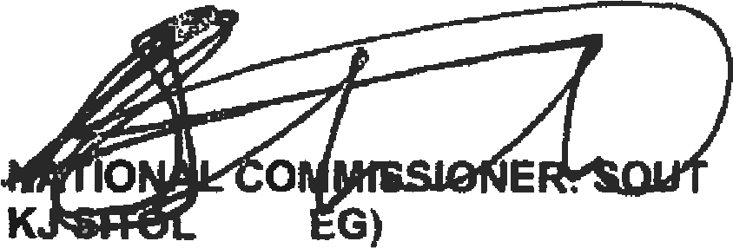
Reply to question 272* recammended/

E (SO

Date: 2l)t1 -t2- 3 6

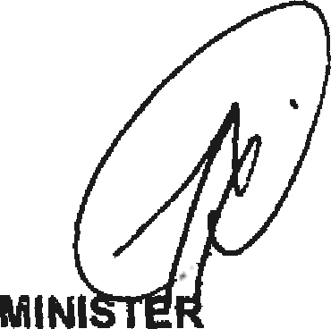
Reply to question 2723 approved/
GENERAL H AFRICAN POLICE SERVICE

OF POLICE
GENERAL E, M

