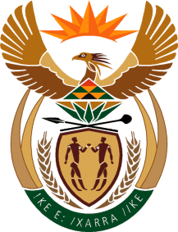

MINISTRY OF TOURISM

REPUBLIC OF SOUTH AFRICA

Private Bag X424, Pretoria, 0001, South Africa. Tel. (+27 12) 444 6780, Fax (+27 12) 444 7027

Private Bag X9154, Cape Town, 8000, South Africa. Tel. (+27 21) 469 5800, Fax: (+27 21) 465 3216

Ref: TM 2/1/1/10

NATIONAL ASSEMBLY:

QUESTION FOR WRITTEN REPLY:
Question Number: 2723
Date of Publication: 31 July 2015
NA IQP Number: 26
Date of Reply: 13 August 2015

Ms S P Kopane (DA) to ask the Minister of Tourism:

(1) (a) What was the cost of the building of the Metsi Matsho Resort in QwaQwa in Free State and (b) when will the project be completed;

(2) Whether, in view of the poor financial management in the Maluti-a-Phofung Local Municipality which is subject to National Treasury intervention, this project will be handed over to them; if not, what are the relevant details; if so, what measures are in place to ensure that the specified resort is managed efficiently? NW3154E

Reply:
- (a)The Metsi Matsho project is being built over two phases. The budget of the first Phase was R26, 125,000 and the expenditure incurred was R25, 734,505. The second Phase is under implementation. The budget for the second Phase is R28, 851,326.00 and the expenditure as at 31 July 2015 is R10, 964,585.

(b) The first phase started around August 2011 till October 2013. The second Phase commenced in February 2015 and is expected to be completed in January 2016.

(2) Due to the fact that the land belongs to the community, a Trust has been registered and ownership of the project will ultimately vest with the Trust with the support of the Local Municipality. The department will be assisting the Trust to appoint a private sector operator, to ensure that an operator is in place by the time the project is completed. This will be undertaken through a consultative process with the community and will adhere to the PFMA regulations and principals of Supply Chain Management.

