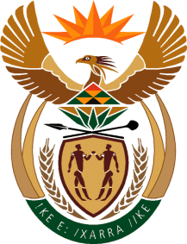

MINISTRY OF TOURISM

REPUBLIC OF SOUTH AFRICA

Private Bag X424, Pretoria, 0001, South Africa. Tel. (+27 12) 444 6780, Fax (+27 12) 444 7027

Private Bag X9154, Cape Town, 8000, South Africa. Tel. (+27 21) 469 5800, Fax: (+27 21) 465 3216

Ref: TM 2/1/1/10

NATIONAL ASSEMBLY:

QUESTION FOR WRITTEN REPLY:
Question Number: 2722
Date of Publication: 31 July 2015
NA IQP Number: 26
Date of Reply: 18 August 2015

Mr A M Figlan (DA) to ask the Minister of Tourism:

Does his department have any information that there has been a noticeable impact on the arrival and departure of travellers from various African countries since the outbreak of xenophobic violence against foreign nationals in Gauteng and KwaZulu-Natal earlier this year? NW3153E

Reply:

The Statistics South Africa monthly Tourism and Migration Statistical Release provides the available detailed information on arrivals and departures including in transit travelers. The number of tourists excludes in transit travelers and there was a year on year decrease for the period January to end April 2015 of 169 017 tourist arrivals, a decline of 7.19%, from the Africa continent. This was made up of a decline of 169 017 (7.1%) in tourism arrivals from SADC and a decline of 7 073 (11%) from the rest of the continent.
The reasons for the decline in arrivals from the African continent is not necessarily entirely attributable to the unfortunate attacks on foreign nationals.

