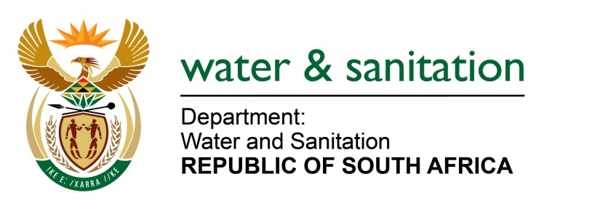

NATIONAL ASSEMBLY

FOR WRITTEN REPLY

QUESTION NO 2721

DATE OF PUBLICATION IN INTERNAL QUESTION PAPER: 8 SEPTEMBER 2017
(INTERNAL QUESTION PAPER NO. 32)
2721. Mr L J Basson (DA) to ask the Minister of Water and Sanitation:
(a) What is the current progress of the (i) blue and (ii) green drop assessments of her department, (b) by what date is the final assessment report expected, (c) what is the projected total cost of each assessment and (d) who will conduct the assessments in each case? NW3028E
---00O00---
REPLY:
(a)(i) The Blue drop progress assessments for 2015 data have been completed and the progress assessments for 2016 data will only be initiated in the last quarter of 2017/18.
(ii) The Green drop progress assessments for 2015/16 are currently in progress.2015/16 are currently in progress.
(b) The blue drop progress assessment report for 2015 data is currently being edited and will be submitted for approval. The 2015/16 draft Green drop progress report will be developed in the first quarter of 2018/19.
(c) The blue drop and green drop progress assessments are currently being done internally.
(d) The full assessments will be done by departmental staff with the support of a service provider. The estimated cost of using external resources is R10.6 million for 2017/18 (blue drop progress and green drop full assessments).

---00O00---

