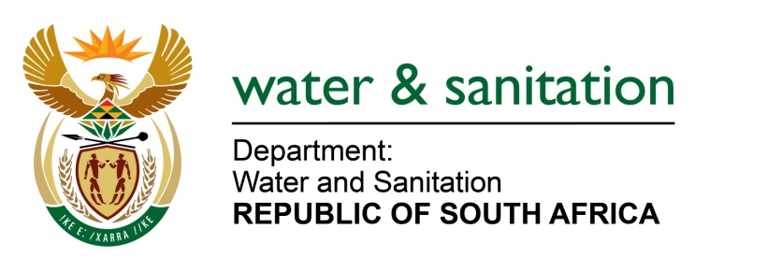

NATIONAL ASSEMBLY

FOR WRITTEN REPLY

QUESTION NO 2720

DATE OF PUBLICATION IN INTERNAL QUESTION PAPER: 8 SEPTEMBER 2017
(INTERNAL QUESTION PAPER NO. 32)
2720. Mr L J Basson (DA) to ask the Minister of Water and Sanitation:
With reference to her reply to question 581 on 3 May 2017, (a) what is the current amount owed by her department to the 15 water boards and (b) in each case, (i) what is the name of the water board owed, (ii) what amount is outstanding and (iii) on what date will the amounts be paid? NW3027E
---00O00---
REPLY:
- My Department is currently owing R47 803 754.46 to three (3) Water Boards as at 13 December 2017 as per the table below:
(b)(i) Name of Water Board | (b)(ii) Amount | (b)(iii) Expected date of payment
Sedibeng Water Board | R 29 930 475.82 | 20 December 2017
Rand Water Board | R 11 842 268.80 | 20 December 2017
Bloem Water Board | R 6 031 009.84 | 20 December 2017
Total | R 47 803 754.46

---00O00---

