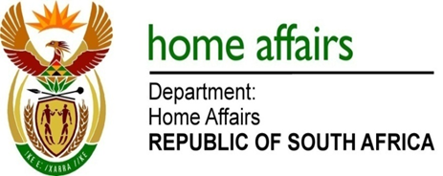

NATIONAL ASSEMBLY

QUESTION FOR WRITTEN REPLY

QUESTION NO. 2699

DATE OF PUBLICATION: FRIDAY, 8 SEPTEMBER 2017

INTERNAL QUESTION PAPER 32 OF 2017

2699. Mr R A Lees (DA) to ask the Minister of Home Affairs:

(a) What is the total amount of funding that the Independent Electoral Commission has paid to (i) political parties, (ii) independent public representatives in local government and (iii) independent election candidates (aa) in each of the past three financial years and (bb) since 1 April 2017, (b) what are the details of the methods used to determine the (i) total allocations and (ii) allocations to each political party, independent public representatives in local government and independent election candidates, (c) on what dates were the specified allocations paid and (d) what were the funds utilised for in each case? NW3006E
REPLY:

(a)(i)(aa) The information in the table below:

2014/2015 FY | 2015/2016 FY | 2016/2017 FY
R121,451,110 | R127,394,146 | R133,719,172

(a)(i)(bb) R66,859,586

(a)(ii)(aa) None

(a)(ii)(bb) None

(a)(iii)(aa) None

(a)(iii)(bb) None

(b)(i) There is a parliamentary allocation plus the bank balance at the end of the financial year minus administrative expenses. This amount is Gazetted each year by the middle of April.
(b)(ii) Allocations to each represented political party are made on a proportional and equitable basis.

Proportional allocation (90% of total allocation) – The number of seats a party has in the National Assembly and provincial legislatures together divided by the total number of seats (currently 830) multiplied by 90% of the total allocation.

Equitable allocation (10% of total allocation) – Divide the equitable portion between the 9 provinces in accordance with the number of seats parties hold collectively in each province, and allocate each provincial amount equally to represented parties in that province, i.e. total number of seats in a province held collectively by all parties in that province divided by the total number of seats in all provinces (currently 430) multiplied by 10% of the total amount and then divided equally among all parties in that province.

(c) Allocations to represented political parties are made in April, July, October and January of each financial year as per the Regulations pertaining to the Public Funding of Represented Political Parties Act 103 of 1997.

(d) Funds were utilised for purposes arising from the functioning of the respective political parties in a modern democracy, classifiable under the following descriptive categories:

- personnel expenditure;
- accommodation;
- travel expenses;
- arrangement of meetings and rallies;
- administration; and
- promotions and publications.

The purposes and categories are defined in the Public Funding of Represented Political Parties Act 103 of 1997 and its Regulations.

Remarks: Reply: Approved / Not Approved

Mkuseli Apleni Prof. Hlengiwe Mkhize, MP
Director-General Minister of Home Affairs
Date: Date:

