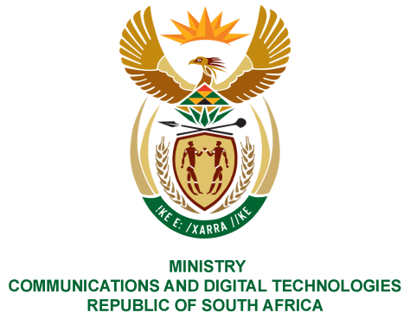
PARLIAMENT OF THE REPUBLIC OF SOUTH AFRICA
NATIONAL ASSEMBLY
WRITTEN REPLY

QUESTION NO: 2698
DATE OF PUBLICATION: 13 NOVEMBER 2020
QUESTION PAPER NO: 47

Mrs M O Clarke (DA) to ask the Minister of Communications [Interdepartmentally transferred from the Minister of Public Service and Administration with effect 20 November 2020]:
With reference to a certain post (details furnished) within the Department of Communications being filled by a Ms Kamogelo Mgotsi, what (a) is the level of the specified position and (b) level was the specified person appointed at?

REPLY:

I have been advised by the Department as follows:-

The person in question is not an employee of the Department of Communications and Digital Technologies.

MS. STELLA NDABENI-ABRAHAMS, MP
MINISTER OF COMMUNICATIONS AND DIGITAL TECHNOLOGIES

