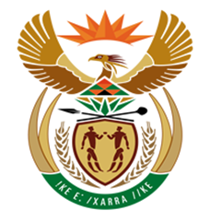

NATIONAL ASSEMBLY

QUESTION FOR WRITTEN REPLY
QUESTION NUMBER: 2697 [NW3004E]
DATE OF PUBLICATION: 08 September2017
2697. Mr R A Lees (DA) to ask the Minister of Finance:
(a) How many applications were received for the special voluntary disclosure programme that closed on 31 August 2017, (b) what is the value of each application, (c)(i) how many of the specified applications were received from each economic sector and/or person and (ii) to what value in each case, (d) how many of the specified applications have been processed to date and (e) what is the total amount of revenue that (i) has been collected from processed applications and (ii) is expected to be collected from unprocessed applications? NW3004E
REPLY:

- Two thousand and two (2002) SVDP applications were received by 31 August 2017.

- The gross value of foreign assets declared, based on the 40% inclusion, is R34 939 070 557. The values of the individual declarations range from zero Rands to 1.4 Billion Rands.

We note that some taxpayers have disclosed 100% of the value of foreign assets on the application forms as opposed to only 40%. SARS is verifying the information submitted and will only be in a position to finalise this value once all applications have been verified.

- (i) SARS is also not in a position to confirm the number of applications by economic sector at this stage.
(ii) This will be confirmed once the verification process has been concluded.
- Of the 2002 applications received, three hundred and five (305) applications have been processed, resulting in two hundred and eighty (280) SVDP agreements being concluded with tax liabilities totalling R 1 031 627 067.

- (i) Of that amount, R822 381 676 has been collected to date.
(ii) As highlighted above, based on taxpayers’ own declarations, an additional amount of about R4 billion is potentially collectable, however, we are in the process of verifying the correctness of the declarations.

