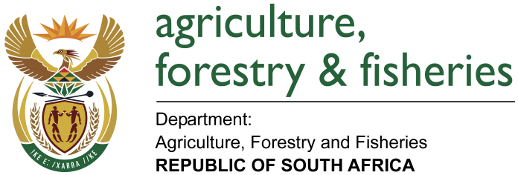
NATIONAL ASSEMBLY

WRITTEN REPLY

QUESTION 2696 / NW 3003E

MINISTER OF AGRICULTURE, FORESTRY AND FISHERIES:
MR P VAN DALEN (DA) to ask the Minister of Agriculture, Forestry and Fisheries:

QUESTION:
Whether, with reference to his reply to question 1523 on 22 June 2017, he received a request to establish a commission of inquiry into the registration process of the Black Boerboel as a breed; if so, (a) when did he establish the commission of inquiry and (b) what progress has the commission made to date in this regard? NW3003E

REPLY:

The Animal Improvement Act (Act No. 62 of 1998) does not make any provision for a Commission of Enquiry but a Committee of Enquiry. The department received a complaint regarding the conduct of the South African Boerboel Breeders Society (SABBS)

(a) (b) The department has initiated a process to request the Minister to a appoint a Committee of Enquiry in terms of section 22 of the Animal Improvement Act (Act No. 62 of 1998) to investigate the complaint.

