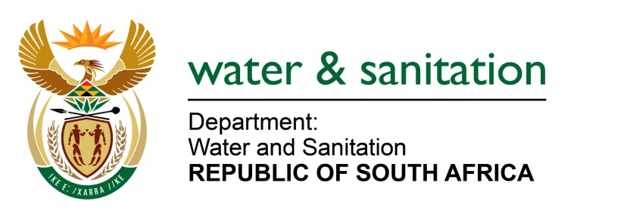

NATIONAL ASSEMBLY

FOR WRITTEN REPLY

QUESTION NO 2695

DATE OF PUBLICATION IN INTERNAL QUESTION PAPER: 31 JULY 2015
(INTERNAL QUESTION PAPER NO. 26)

2695. Mrs Z B N Balindlela (DA) to ask the Minister of Water and Sanitation:

Whether (a) she, (b) her Deputy Minister and (c) any officials in her department travelled to China in the 2014-15 financial year; if so, what was the (i) purpose of each specified visit and (ii)(aa) total cost and (bb) breakdown of such costs of each specified visit? NW3126E
---00O00---
REPLY:
Neither me, the Deputy Minister of Water and Sanitation, nor any officials of my Department travelled to China during the 2014-2015 financial year.
---00O00---

