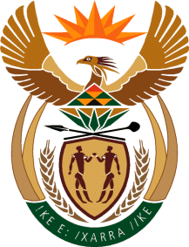

MINISTRY OF TOURISM
REPUBLIC OF SOUTH AFRICA

Private Bag X424, Pretoria, 0001, South Africa. Tel. (+27 12) 444 6780, Fax (+27 12) 444 7027
Private Bag X9154, Cape Town, 8000, South Africa. Tel. (+27 21) 469 5800, Fax: (+27 21) 465 3216

NATIONAL ASSEMBLY:

QUESTION FOR WRITTEN REPLY:
Question Number: 2694
Date of Publication: 13 November 2020
NA IQP Number: 47
Date of reply: 05 November 2020

Mr M S F de Freitas (DA) to ask the Minister of Tourism:
With reference to the World Economic Forum’s Global Future Council on Sustainable Tourism and her membership thereof, (a) what are the relevant details of the innovative thinking proposals that she will be presenting at the Council and (b) by what date will the specified proposals be tabled? NW3462E

REPLY:

- What are the relevant details of the innovative thinking proposals that the Minister will be presenting at the Council?
Membership to a Global future council by invitation only. Minister participates in this forum with other experts to provide strategic insights, scientific evidence, forward guidance and multidisciplinary understanding of major issues that will shape the post-COVID world. Most of the discussions are held under the Chatham House Rule.
For more information visit:https://www.weforum.org/communities/global-future-councils

- By what date will the specified proposals be tabled?
Not applicable.

