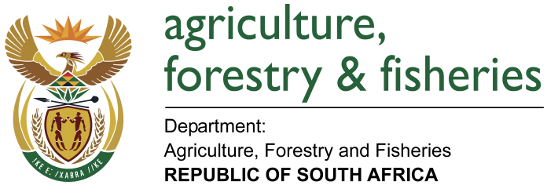
NATIONAL ASSEMBLY

WRITTEN REPLY

QUESTION 2694 / NW 3001E

MINISTER OF AGRICULTURE, FORESTRY AND FISHERIES:
MS A STEYN (DA) to ask the Minister of Agriculture, Forestry and Fisheries:

QUESTION:
(a) How many official international trips did (i) he and (ii) the Deputy Minister undertake since 26 May 2014 and (b) what was the (i) destination, (ii) purpose, (iii) name of each member of the delegation, (iv) cost of flights, (v) cost of accommodation and (vi) subsistence costs for each person in each case? NW3001E

REPLY:
Is Attached

