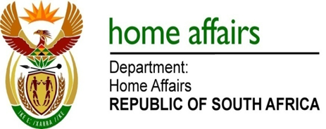

NATIONAL ASSEMBLY

QUESTION FOR WRITTEN REPLY

QUESTION NO. 2687

DATE OF PUBLICATION: Friday, 31 July 2015

INTERNAL QUESTION PAPER 26 OF 2015

2687. Mr M H Hoosen (DA) to ask the Minister of Home Affairs:

Whether (a) he, (b) his Deputy Minister and (c) any officials in his department travelled to China in the 2014-15 financial year; if so, what was the (i) purpose of each specified visit and (ii)(aa) total cost and (bb) breakdown of such costs of each specified visit?
NW3118E
REPLY:

(a-b) Neither the Minister nor Deputy Minister travelled to China during the 2014-15 financial year.

(c) The table below indicates the officials who travelled to China in the 2014-2015 financial year:

OFFICIAL | - PURPOSE | (ii)(aa-bb) COSTS
DDG: Immigration Services,  JW McKay | Study Tour on Integrated Border Management | Total: R 115 845.02  Flight: R 90 626.50  S&T: R 4 048.52  Accommodation: R 7 806  Ground transport: R 13 364
Director: Core Business and Change Audits, LT Kgopane  Assistant Director: Audits, NS Somdyala | Audit of DHA services in SA mission in Shanghai | Total: R 129 959.68  Flight: R 28 409.39  S&T: R 9 055.45  Accommodation: R 22 944  Ground transport: R 4 571  Flight: R 28 409.39  S&T: R 9055.45  Accommodation: R 22 944  Ground transport: R 4 571
OFFICIAL | - PURPOSE | (ii)(aa-bb) COSTS
DDG: Immigration Services, JW McKay  Director: Corporate Accounts, IP Mbhele | Bilateral discussions on immigration and official visit to SA missions in Beijing and Shanghai, respectively | Total: R 161 444.82  Flight R 61 547.39  S&T: R 4 541.52  Accommodation: R 19 441  Ground transport: R 9 285  Flight: R 38 597.39  S&T: R 4 541.52  Accommodation: R 14 206  Ground transport: R 9 285
Senior Accounting Clerk: Foreign Revenue, V Andrews | Accompanied Auditor – General officials to conduct regulatory audit of SA mission in Shanghai | Total: R 89 766.64  Flight: R 54 165.22  S&T: R 8 520.42  Accommodation: R 17 106  Ground transport: R 9 975

