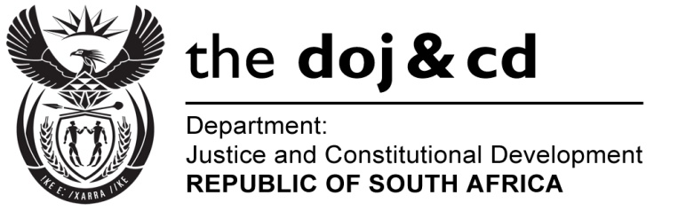

NATIONAL ASSEMBLY
QUESTION FOR WRITTEN REPLY
PARLIAMENTARY QUESTION NO.: 2684
DATE OF QUESTION: 31 JULY 2015
DATE OF REPLY: 14 AUGUST 2015

Adv G Breytenbach (DA) to ask the Minister of Justice and Correctional Services:

Whether (a) he, (b) his Deputy Ministers and (c) any officials in his department travelled to China in the 2014-15 financial year; if so, what was the (i) purpose of each specified visit and (ii)(aa) total cost and (bb) breakdown of such costs of each specified visit?

NW3115E
REPLY:
I wish to inform the Honourable Member that (a) neither I nor the former Minister of Justice and Constitutional Development travelled to China during 2014-15;
(b) the Deputy Minister of Justice and Constitutional Development did not travel to China during 2014-2015; and
(c) I have been informed that no officials from the Department of Justice and Constitutional Development or from the Office of the Chief Justice, travelled to China during the 2014-15 financial year.
(i) and (ii) therefore fall away.

