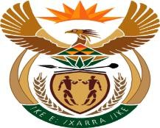

MINISTRY: PUBLIC SERVICE AND ADMINISTRATION REPUBLIC OF SOUTH AFRICA

NATIONAL ASSEMBLY QUESTION FOR WRITTEN REPLY
DATE: 3 DECEMBER 2021

QUESTION NO.: 2681.

[⬇382] [Question submitted for oral reply now placed for written reply because it is in excess of quota (Rule 137(8))]:

MRS C C S MOTSEPE (EFF) TO ASK THE MINISTER OF PUBLIC SERVICE AND ADMINISTRATION:

(a) To which position in Government has a certain person (name furnished) been employed and (b) what processes were followed in the employment of the specified person to the new position? NW3181E

REPLY:

The Department of Public Service and Administration (DPSA) is not the employer of the individual. It is widely known that the individual was employed by the Presidency therefore the matter should be referred to the Presidency accordingly.

End

