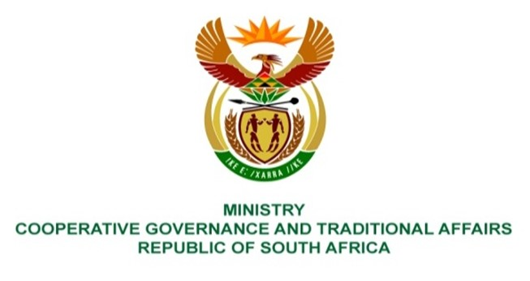

NATIONAL ASSEMBLY
QUESTIONS FOR WRITTEN REPLY

QUESTION NUMBER 267

267. Mr C Brink (DA) to ask the Minister of Cooperative Governance and Traditional Affairs:
(1) Whether she, any organisation and/or association in which she has or had any interest of any kind and/or in which she exercises or exercised influence or control ever received a donation in money or in kind from a certain company (name furnished) and/or any company trading under the specified name and/or any person(s) (names furnished) and/or any other person who is or has been a director, associate and/or employee of the specified company and/or any company trading under the specified name; if not, what is the position in this regard; if so,
(2) whether she has complied with all statutory requirements relating to the disclosure of each such donation; if not, why not; if so, what are the relevant details? NW271E
REPLY:

Since the query is being posed in her individual capacity, it should be directed to the Minister in the Presidency for Women, Youth, and Persons with Disabilities.

End.

