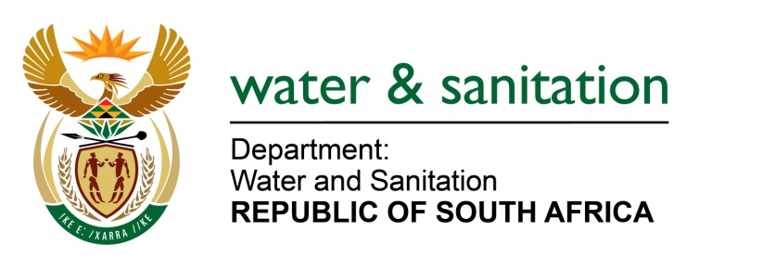

NATIONAL ASSEMBLY

FOR WRITTEN REPLY

QUESTION NO 2660

DATE OF PUBLICATION IN INTERNAL QUESTION PAPER: 31 JULY 2015
(INTERNAL QUESTION PAPER NO. 26)

2660. Mr W Horn (DA) to ask the Minister of Water and Sanitation:
(1) How many households in the jurisdictional area of the Mangaung Metropolitan Municipality made use of (a) bucket system serviced toilets (b) VIP toilets and (c) pit latrines from (i)(aa) 31 May 2011 and (bb) each calendar year till 31 May 2015 and (ii) 1 June 2015 up to the latest date for which information is available;
(2) how many households in the specified municipality are expected to still be using the (a) bucket system serviced toilets (b) VIP toilets and (c) pit latrines by 31 May 2016? NW3091E
---00O00---
REPLY:
(1)(b) The official figure for bucket toilets in the Metro area is 1 585 but a recent survey has indicated that 1 347 buckets are being removed in Mangaung and 757 in Botshabelo giving a total of 2 104. It must however be noted that the majority of these buckets are on informal sites and that all bucket toilets have been eradicated in Thaba Nchu.

(1)(b) The Mangaung Metro has a total of 33 382 VIP toilets.
(1)(c) The spread sheet depicts the number of pit latrines as per a financial year as requested:
HHs with Sanitation Services in MMM
Month Year | Pit Latrines
(aa) May-11 | 33 745
(bb) May-12 | 32 998
(bb) May-13 | 31 255
(bb) May-14 | 30 825
(bb)May-15 | 29 823
(ii)(bb) May-16 | 28 437

(2) Mangaung Metro Municipality has committed itself to eradicate the sanitation backlog which includes all bucket and VIP toilets by 2018. With the current bucket and VIP eradication program, the Metro is expected to have the following backlog which will be addressed annually until the above mentioned eradication date:

HHs with Sanitation Services in MMM
Month Year | (2)(a) Buckets Toilets | (2)(b) Pit Latrines | (2)(c) VIPs
May-16 | 1 223 | 28 437 | 31 468

---00O00---

