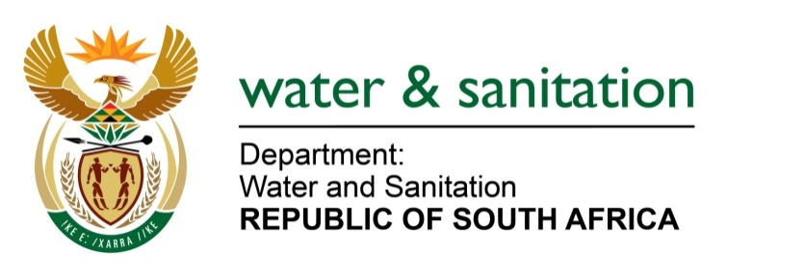

NATIONAL ASSEMBLY

FOR WRITTEN REPLY

QUESTION NO 2656

DATE OF PUBLICATION IN INTERNAL QUESTION PAPER: 25 NOVEMBER 2016
(INTERNAL QUESTION PAPER NO. 40)
2656. Mr L J Basson (DA) to ask the Minister of Water and Sanitation:
(a) What is the working status of the pumps delivering water from the Heyshope Dam in the Usutu catchment to the Vaal River upstream of Grootdraai Dam, (b) what was the capacity transferred in each month in the (i) 2015 and (ii) 2016 calendar years, (c) how many of the pumps worked during the specified period and (d) what amount was spent on the pumps during the period? NW3140E
---00O00---

REPLY:

(a) At Heyshope pump-station there are 4 pump-sets of which 2 pump-sets are currently functional and in operation. At Geelhoutboom pump-station there are also 4 pump-sets of which 2 are in operation. These two pump-stations are operating in series together with long sections of gravitational transfers.
At Heyshope refurbishment of the booster motor at pump-set 1 is underway and procurement for the mechanical motor and control valve refurbishment is in progress. At Geelhoutboom line 1 the motor refurbishment is being completed and it is anticipated that it will be back in operation by January 2017. The other pump-set is awaiting the replacement of bearings which is in progress and should be back in operation by December 2016.

(b)(i) The volume of water transferred in 2015 was 27, 9 million cubic meters

(b)(ii) The volume of water transferred in 2016 is 43, 7 million cubic meters.

(c) In 2015 Heyshope had 3 out of 4 pump-sets in operation and 2 out of 4 in 2016. At Geelhoutboom 1 out of 4 was operational in 2015 and this improved to 2 out of 4 in 2016.

(d) Since the rectification work is not completed as yet, a final figure is not available as yet. However to date R97.7million was spent at these two pump-stations.
---00O00---

