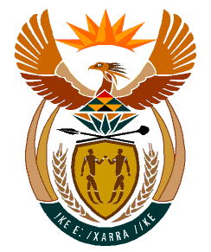

MINISTRY
HUMAN SETTLEMENTS
REPUBLIC OF SOUTH AFRICA

Private Bag X645, Pretoria, 0001. Tel: (012) 421 1309, Fax: (012) 341 8513

Private Bag X9029, Cape Town, 8000. Tel (021) 466 7603, Fax: (021) 466 3610

NATIONAL ASSEMBLY QUESTION
QUESTION FOR WRITTEN REPLY
QUESTION NUMBER: 2641

DATE OF PUBLICATION: 26 November 2021

DATE OF REPLY: 07 December 2021

492 Ms N Tafeni(EFF) to ask the Minister of Human Settlements:

(a) What total number of (i) Chief Director and, (ii) Deputy Director-General positions are occupied by persons on an acting basis in her department and (b) by what date is it envisaged that the positions will be filled by permanent employees? NW3123E

REPLY:

Honourable Member, here is the reply:

- There are currently two employees acting in higher positions:
- Chief Director: Communications
- Deputy Director-General: Informal Settlement Upgrading and Emergency Housing

- The Chief Director: Communication was advertised and shortlisting is scheduled to take place before 20 December 2021, with the interview taking place before the end of January 2022. The Deputy Director-General post will be advertised by 28 January 2022 and be filled by the end of the financial year (31 March 2022).

