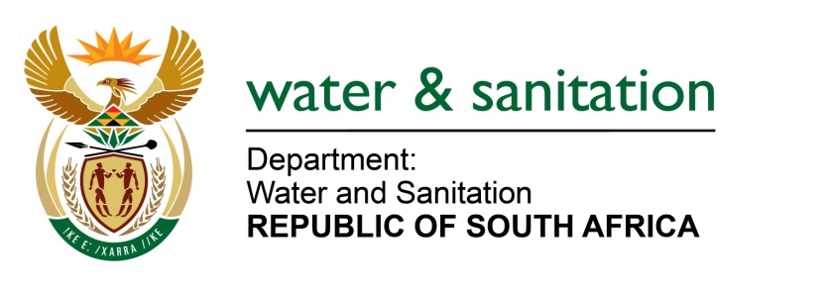

NATIONAL ASSEMBLY

FOR WRITTEN REPLY

QUESTION NO 264

DATE OF PUBLICATION IN INTERNAL QUESTION PAPER: 19 FEBRUARY 2016
(INTERNAL QUESTION PAPER NO. 2)

264. Ms M S Khawula (EFF) to ask the Minister of Water and Sanitation:
Whether she and/or her department has bought advertising space in The New Age in the (a) 2012-13, (b) 2013-14 and (c) 2014-15 financial years; if so, (i) what number of times and (ii) for what amount in each specified financial year? NW268E
---00O00---
REPLY:

- Yes, my Department did buy advertising space in The New Age. Refer to the table below for the break down per financial year.

Financial Year | Number of times | Amount
(a) 2012/13 | Once (1) | R97 723.08
(b) 2013/14 | Five (5) | R 175 091.40
(c) 2014/15 | Thirteen (13) | R 953 887.97

---00O00---

