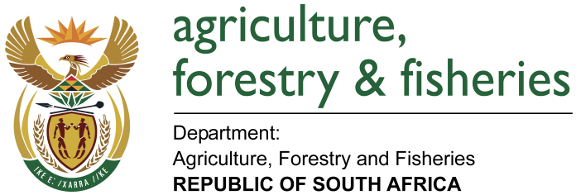
NATIONAL ASSEMBLY

WRITTEN REPLY

QUESTION 2636 / NW 2924E

MINISTER OF AGRICULTURE, FORESTRY AND FISHERIES:
Ms A Steyn (DA) to ask the Minister of Agriculture, Forestry and Fisheries:

QUESTION:
(1) Whether his department drafted new inspection regulations on food safety; if so, (a) what are the relevant details of the new regulations, (b) what is the intended specific purpose of each regulation, (c) which industries are affected by the new regulations, (d) how will the implementation of the new regulations be monitored and (e) what will the cost impact be on industry;
(2) has his department put any measures in place to mitigate the cost impact; if not, what is the position in this regard; if so, what are the relevant details;
(3) whether industry stakeholders were consulted prior to the promulgation of the new food safety regulations; if not, why not; if so, what are the relevant details? NW2924E
REPLY:
(1) The department has not recently drafted any new inspection regulations on food safety. The only food safety legislation administered by the department is the Meat Safety Act (Act No. 40 of 2000). The other food safety legislations are administered by the National Department of Health (NDoH) and the National Regulator for Compulsory Specifications (NRCS) which is an entity under the Department of Trade and Industry (the dti).

