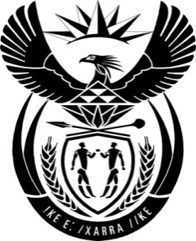

THE PRESIDENCY: REPUBLIC OF SOUTH AFRICA
Private Bag X1000, Pretoria, 0001
NATIONAL ASSEMBLY
QUESTIONS FOR WRITTEN REPLY

QUESTION NO: 2635
Date Published: 25 November 2016

Ms D Carter (Cope) to ask the President of the Republic:
Whether, with reference to his statement at the Royal Bafokeng regarding the responsibility to fight corruption (details furnished) and his recent statement in Pietermaritzburg that he knows the thieves who are stealing (details furnished), he has reported these corrupt transactions to the SA Police Service; if not, why not; if so, what are the details of the cases? NW3116E

Reply
We have instructed the Anti-Corruption Task Team to work tirelessly to root out corruption at all levels of the public services where it exists. A lot of good work has been done as reported recently by the Anti-Corruption Inter Ministerial Committee.

In some of the progress made, since April 2013 I have signed more than 27 proclamation orders which has resulted in the Special Investigating Unit recovering cash or assets to the value of R204 million and managed to have contracts to the value of R755 million cancelled. Over the past three years 32 people involved in corruption cases worth R3 billion have been convicted. 58 people involved in fraud to the value of close to R200 million were also convicted.

We are committed to do even more to defeat the scourge of corruption. We do not only talk about fighting corruption, but we are doing something about it. The few cases I have mentioned above attest to the progress we are making.

We will continue to speak out to discourage unethical behaviour and to discourage those who may be tempted. The statement was made in that spirit.

