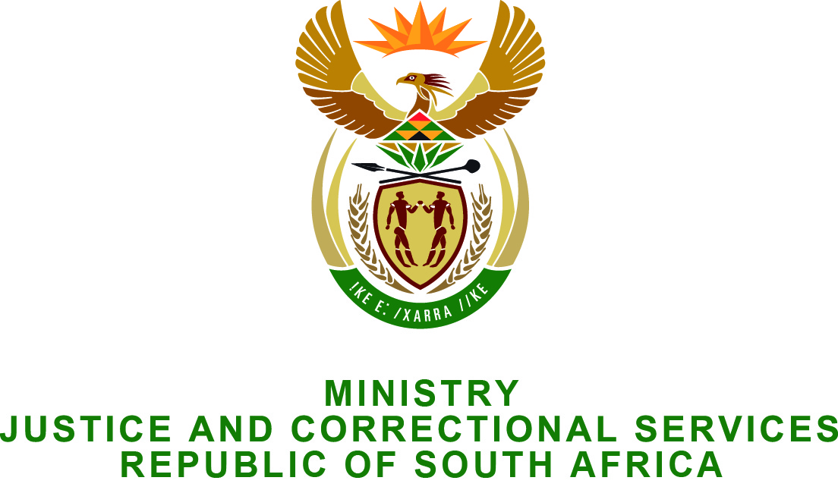

NATIONAL ASSEMBLY
QUESTION FOR WRITTEN REPLY
PARLIAMENTARY QUESTION NO.: 2634
DATE OF QUESTION: 24 JULY 2015
DATE OF REPLY: 07 AUGUST 2015

Adv A de W Alberts (FF Plus) to ask the Minister of Justice and Correctional Services:†
Whether, in light of South Africa’s international and domestic legal obligations, a court order for the arrest of president Omar al-Bashir of the Sudan for genocide was at any stage issued in terms of the legislation which grants the International Criminal Court jurisdiction in South Africa; if not, why not: if so, what are the relevant details? NW3009E

REPLY:
The Minister wishes to inform the Honorable member that at the time the original genocide warrant was issued by the International Criminal Court in July 2010 against President Al Bashir, the Department of Justice and Constitutional Development received confirmation from the Department of International Relations and Cooperation (DIRCO) that the second warrant relating to genocide charge and accompanying statements had been dispatched but that it had not been received at the Department for processing.
Following the receipt of this Parliamentary question, the Department has since forwarded a request to DIRCO urging them to obtain confirmation from South Africa’s Mission in The Hague of the specific date upon which the original genocide warrant was transmitted to DIRCO for onward transmission to DOJCD. The Department therefore awaits a response in this regard from our Mission in The Hague.
As there had been difficulty locating the whereabouts of the original genocide warrant, the Magistrate’s Court for the District of Pretoria has not as yet been seized with the task of endorsing and ultimately issuing the second warrant against President Al Bashir for crimes of genocide for which he has been indicted by the International Criminal Court on 12 July 2010.

